September-October 2021

**Chapter Leader: Theresa Phillips TCF National Headquarters**

# 24-Hour Help Line: (816)229-2640 48660 Pontiac Trail #930808 Wixom, MI 48393

**Private Facebook Page: Eastern Jackson County TCF Website: www.compassionatefriends.org**

**Website: www.easternjacksoncounty tcf.org (877)969-0010**

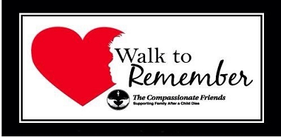

Eastern Jackson County Annual Walk to Remember is scheduled for September 18, 2021, at Waterfall Park, right behind Bass Pro in Independence, MO. Registration will start at 8:30 AM. Walk will begin at 9 AM. More information about the event can be located on the website www.easternjacksoncountytcf.org.

**How Does a Grieving Kid**

**Deal With School?**

Going back to school is always tough, but when there has been a death in your family, it’s really hard. You wonder how your friends will treat you. You don’t think you can concentrate or listen very well because your mind feels confused. You worry how the rest of your family will be without you around. You feel so different, and school is sure to be just the same! …

Sometimes kids and teachers don’t know what to say, so they say something dumb or don’t say anything at all. Some days it can seem almost impossible to keep from crying in front of people. Everyone thinks you should be “over it” right away.

Dana (age 12): “Fortunately the kids treated me very considerately. But the teacher wasn’t as nice. She thought I was using my father’s death to make her go easy on me. But as all of us know, that’s not how it is. We can’t help it if we get upset, but some people don’t understand.”

School can be very hard for a kid who is grieving the death of a loved one. Some things that might help a little are: Talk with your teacher about what you want the class to know about the death and who should tell them. Make a plan with your teacher, so you can leave the room if you start feeling upset. Try to find a safe quiet place to go: the library, the nurse’s office, etc. If people ask you questions that you don’t want to answer, say something like, “I’d rather not talk about that right now.” Try to find at least one person who you feel comfortable talking to when you want to talk. Or start to write your thoughts in a journal.…

If you are bothered by what other kids say, try to talk to them and get them to understand that you need their support. If that doesn’t work, talk with your teacher or a parent. If you think your teacher doesn’t understand, do your best to talk with her, and bring in an understanding adult to help if necessary.

To keep up with your homework, maybe you could study with a friend or get an older student to help you or ask your teacher for some extra time. As long as you are really trying, that’s all anyone should ask of you.

As you go through the school year there will be some good days and some tough ones. Don’t be upset if you don’t do as well as usual on grades, or if you have trouble getting along with your same old friends.Be patient with yourself because you want others to do the same for you.

Grief is a long process that changes people, and change can be tough. But change can bring good things too. Perhaps you will find yourself appreciating the little things more, or being kinder to people, or wanting to make the most of your time, or developing an ability to express yourself creatively. These are things you don’t normally learn in school, but these are things you learn from living.

*--By Dana Ward, Erin Helmer & Barb Coe*

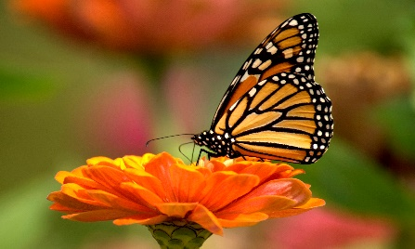

**Why Butterflies?**

Since the early centuries of the Christian church, the butterfly has symbolized life after death. The caterpillar signifies life here on earth; the cocoon—death, and the butterfly—emergence of the dead into a new beautiful, more free existence. Frequently the butterfly is seen with the word “Nika,” which means victory. Elizabeth Kubler-Ross tells of seeing butterflies drawn all over the walls of the children’s dormitories in the World War II concentration camps.… She concludes that these children knew their fate and were leaving a message.

The Compassionate Friends has adopted the butterfly as one of its symbols—a symbol of new life, of hope to us that our children are living in another dimension.

Before a caterpillar becomes a butterfly, though, it must spend time in a cocoon. We might be tempted to help release the butterfly from her cocoon. It is human nature to want to assist, but if we do, she will fall to the ground and die. Through her struggle to free herself, she strengthens her wings enough to survive and fly.

Grief is certainly like this process. We feel ugly, we change, we hide, we sometimes spin a cocoon around ourselves. It takes a long time. There is a difference, however; others may help us as we struggle. We need not do it all alone as the butterfly does, but the ultimate responsibility is ours. We have to grieve, hurt, cry, be angry, and struggle to free ourselves from the cocoon of grief. And one day, we do emerge—a stronger person, a more compassionate person—a beautiful butterfly.

**School Supplies**

I bought a BIG CHIEF tablet today. I really didn’t have any reason to buy it. My daughter is in college and would probably die if I suggested she take notes on a BIG CHIEF tablet. And my son, who did die, probably doesn’t need one either. (I have this magical view of Heaven where notes and homework and dishes and laundry don’t exist.) But, as I passed the aisle marked “School Supplies,” I suddenly wanted a BIG CHIEF tablet, so I turned down that aisle and journeyed backward to a time when we once bought school supplies.

I hadn’t been down an aisle like that in years. But, as I fingered all the different colored folders, and noticed crayons that used to have simple names like “red” & “green” which are now called “rouge” and “forest,” I drifted. The memories returned. I found myself searching the piles of notebooks for just the “right one.” And I must have gone through 20 lunch boxes before I found one that suited me—not too immature, with enough space so a sandwich would not become a pancake before recess. And, of course, a sturdy thermos with the latest hero emblazoned on the outside.

The search took quite a long time and before I realized it, I had accumulated enough stuff so that I needed a basket. Funny…I had only come in to pick up some film, and now I needed a basket. The sight of rows upon rows of new pencils filled me with that odd combination of anticipation and dread of the new school year. Do you remember that? I was half excited about the new year and half sad that summer seemed over. The endless hours of evening were about to come to an abrupt end with something called homework. Even a new eraser in the shape of a rocket couldn't eliminate that grief.…

My lunch box was red—all good lunch boxes are red. It always contained some kind of sandwich from home—mostly bologna with catsup, a few chips or crackers, an apple, a thermos of milk

or juice, and maybe a note from Mom

written on the napkin. I always peeked during the bus ride in the morning, and by recess, the deals were made. Trading sandwiches is as old as we are—maybe older. (Adam and Eve probably traded lunches too.) If you were clever, you could parlay half a sandwich into a Twinkie! (My mother never allowed us to have Twinkies. We always got fruit.) But Mom, I LOVED Twinkies. Please forgive me.

My daughter always wanted a bright yellow lunch box, and she loved a new box of crayons almost as much as I did. We would buy two boxes, one for school and one for home. I never put Twinkies in her lunch box either, but I knew she had learned the secret of trading. Apples don’t leave crumbs!

I had visions of the lunch boxes and crayons that our son would need too, and that’s when Dad got into the before-school-shopping-spree game with us. His memories led him to one of those black workmen’s lunch boxes and pickles. He never has been a Twinkies fan, but he could trade with the best of them. He had dreams of passing that down to his children.

But years go by, and eventually, one does not have to turn down that aisle anymore—or perhaps you never did. (Ha! You dropped out of school after kindergarten?) We used to avoid the stores late in summer when the aisles marked the change in seasons. My mother’s words still echo across my mind, “Never mind that it is 102 degrees outside. We must try on these wool sweaters or there won’t be any left when we need them.”

Now we avoid those aisles because such simple things as the smell of new crayons makes a lump in the throat. The feel of new shoes brings back a flood of memories that is only equal to the flood of tears.

Will IT ever get better? Will we ever be able to march down whatever aisle we happen to turn into without fear of memory overload? Will we ever be happy again? Will I ever be able to color again —without watching the tears pool on the paper?

After all these years, I am beginning to understand that the answers aren’t written on a magical calendar somewhere. I used to think that if only enough time would pass, IT would diminish, get smaller, get better, disappear. If only I could work hard enough, read enough books or hear the RIGHT workshop or lecture. If only I looked long enough, the answer would be there, just waiting for me to discover it. I did all the “right” things in my grief. I probably did all the "wrong" things too. Some things worked better or longer than others, but always, the little sense of pain just beneath the surface would follow me. I couldn’t shake it.

I finally understood that little pain-piece is a part of me. It will not go away, but I can manage it (when I feel like it). Sometimes it manages me, and I get swept away with hurt and pain, and guilt and anger come rushing back into focus. Even after all these years, there are bits and pieces of all those feelings left inside. But at other times, different pieces come floating back: the giggles, the warmth of his touch, the fragrance just after a bath, the feeling of a heartbeat so close to mine in an embrace. It’s all there, sometimes tangled and twisted—other times neatly organized and catalogued for reference whenever I need a “memory fix.” We are like a new slate each day, washed clean with each new dawn,

ready to write a new adventure. Yet unlike the clean blackboard (Actually it’s green, because modern technology believes green is easier on the eyes; but who ever heard of it being called a green board?), our chalkboard keeps the traces of yesterday in place to be written over and over, but never truly erased. My chalkboard is filled with all the memories, the good, the bad and yes, the ugly. (Clint Eastwood should now appear…)

The fabric of our lives is often torn and ripped, but it is mended with tiny stitches (tiny challenges, tiny triumphs, tiny yeses!). It is made stronger because of the mends, not weakened by the holes. We do not forget much of anything. It may not always be right at the surface, but no one forgets the feel of new shoes, the smell of new crayons, the taste of a fresh jar of paste (Again, modern technology has robbed our children of the joy of sampling library paste. White glue simply does not have the taste.)

So, knowing it might hurt, I turned down the aisle marked “School Supplies” and let myself travel backward for a few minutes. I have learned that when we try to block out or erase those memories, we end up hurting even more—then we truly do lose something. There are many kinds of grief and many kinds of hurt. But the greatest of them all must be the emptiness of not having any memories at all.

I bought a BIG CHIEF tablet today …mostly because I wanted it and needed to treat myself (a low-calorie, low-fat, high-fiber choice). I wanted to remind myself of my own childhood with its own measures of hurt, pain and sorrow, mystery, joy and adventure. I bought the BIG CHIEF tablet to remind myself of my own children’s journeys too. One is still in the making and one was cut too short. I thought I heard my mom’s voice as I selected just the right one, and I know I heard her chuckle when I put the red lunch box in my basket.

I’m starting a new season, too, Mom. I need a new lunch box. I could use a note on a napkin too. Now I’ll have to write my own note, but the words will come out of memory—the greatest grief and gift of all.

*–Darcie Sims*

**Anger at God After a Child Dies**--Grieving people don’t need their feelings about God stifled or redirected. God can handle the anger of humans without our defense or justification. Anger is a normal, healthy part of the grief process.—*Rev. Al Miles*

**Forever 13**

He would have been a junior

He should have been

on the football team

He could have been a wrestler

*He might have been …*

He would have been 17 this year

He should have been laughing and

running about

He could have been chasing the girls

*He might have been …*

He would have been blowing his

French horn

He should have been giving his

teachers a hard time

He could have been learning how to

drive

*He might have been …*

Except now he is forever 13 …

*--Lorrie Beyl, Colo. Springs, CO, TCF*

**Autumn**

*In the fall when amber leaves are shed,*

*Softly…silently, like tears that wait to flow,*

*I watch and grieve.*

*My heart beats sadly in the fall;*

*It’s then I miss you most of all*

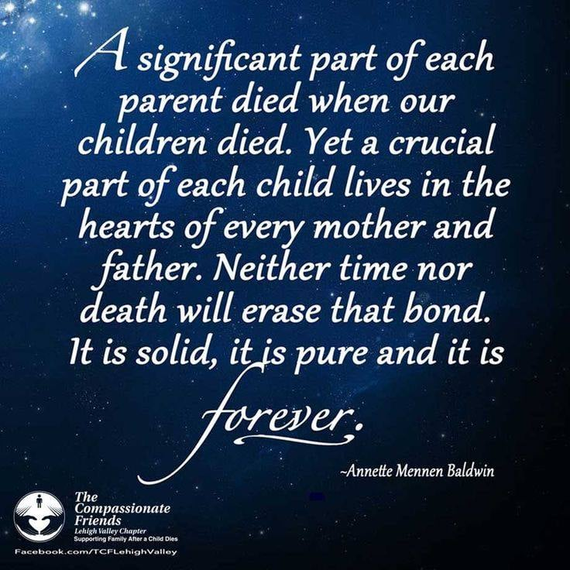**Where Do I Go?**

Now that you’re gone, where do I go

to see your fair smile

to hear your tinkling giggle

to smell your damp hair after a swim

to listen to your questions

to touch your gentle cheek

to feel your bear hug?

Where do I go

to share all my years of wisdom

to find someone who’ll tell me the truth

to answer the phone that won’t ring

to tell you I’m sorry

to know that I am loved and

to pour out my love and my tears?

I shall go

to the pictures that hold you forever

to the books we shared

to the music you taught me to love

to the woods we explored as one

to the memories that never fail

to the innermost reaches of my heart

to where we are always together.

*--Marcia Alig, TCF, Mercer, NJ*

Instead of thinking

I need to get back

to the old “normal,”

perhaps I need to embrace

how I am changed forever

by the death of my loved one.

To do this I have to acknowledge the reality of the death

and be willing to connect

to the deepest parts of myself.

That’s when grief becomes

a growth process

the turmoil of change.

I am new;

I am changed;

I am reborn.

*--Alan D. Wolfelt*

***From Sascha Wagner:***

**Summer’s End**

Always at summer’s end

there comes that moment

when memory brings to me

gifts from the past.

I see your faces then,

glistening in the sun.

I hear your laughter then,

shared by the wind.

And in the glint of time

I feel you near again,

as you were, long ago,

at summer’s end.

**Now Autumn**

What a strange time is autumn.

More than a season,

autumn can be like a mood.

Softness and warmth and abundance

drift from the sky like a smile.

And you remember the seasons

before the children died.

They do seem far away sometimes,

those seasons, now.

But not the children—

they are always here

in this strange time, this autumn,

when the softness and the warmth

and the abundance

of unseen children

drift from the sky like a smile.

**Indian Summer**

This may well be

the softest time of all.

Does mild September

still surprise your mind

with memories you thought

you would not have?

Believe me, friend, that

(after many tears)

this may well be

the softest time of all.

**September**

If we are to believe the calendar, our years end in December and begin in January. But for most of us, our years from childhood on have been marked by the beginning and ending of each school year. The serious stuff of life commenced each September as first we, and then our children, began a new grade. The routine of our days from September until June was governed by the school calendar.…

September—the autumn bridge between summer and winter, between resplendent life rich with green leaves and azure sky, and dull, gray skied barren treed winter. Oh, September—with your multi-colored beauty, Indian summer, clear blue skies—you are a wolf in sheep’s clothing.

For the bereaved, September can be particularly poignant. We believed that summer would last a little longer just this once. And in a way, it has. The long, warm days persist, and the beauty of nature continues. As green leaves are slowly replaced by rich gold, then reddish hues, there is a poignancy to the warmth and beauty of autumn. September is summer’s swan song, the final verse sung in full symphonic chorus. Savoring each lovely day, we delight in the beauty of the changing colors and cling to the vibrancy that will soon be replaced by the barren days of winter.

While schedules are remade and obeyed, vacations end and children return to school, there is a kind of comfortable “sameness” that begins in September and lasts until the following spring. In a way, this predictability is a kind of security.

Still, for those whose lives have been irrevocably changed by death, illness, separation or any other unasked-for life-altering situation, the knowledge that the rest of the world is settling down to “regular” life is an affront. For lives that have lost predictability, “sameness” is now fervently desired and pined for.

The door slams shut, but it is the wind that has closed the door. The footsteps that should follow never come. School buses once again crisscross the September streets, but for bereaved parents, they are only a painful reminder of schedules that are gone, lunches that no longer need to be made, homework that will never be done and checked. Friends’ lives continue and go forward, their children grow and progress; but bereaved parents face September’s settling down to “real” life with leaden hearts.…

Seeing other people planning and sharing their leisurely enjoyment of the season was hard enough in the summer. September can be worse. Hand-in-hand with that month’s almost unbelievable beauty is the knowledge that this beauty is the precursor to winter. During the summer months, the bereaved suffer from the loss of the happy, languid days that were. During September, the nightmare of lost dreams becomes reality. As the rest of the world settles in, the bereaved are left feeling adrift and apart from the mainstream. The rudders that had guided their lives are gone. The acrid smoke from autumn’s burning leaves only reminds them of what was and gives testament to the loss and bitterness that remain.

But what can the bereaved learn from the change of the seasons? What can any human being learn from the cycle that is nature? We change, and we remain the same. We grow and we bloom, but we also experience dormant periods. A plant grows and blooms and changes with the seasons. One month, a green, tender shoot; the next, a riot of color. In the next season, it can be bearing fruit for the future of its species, while at the same time beginning its own slowing down, preparing for its dormancy. The winter, barren of leaf, is a resting time, a dormancy, a preparation for the new growth that will occur in the spring.

A plant with strong roots can regrow after being pruned. It may grow in a different direction & into a different shape, depending on the sunlight, nutrients and pruning. But in spring, after its long-frozen sleep, its tender shoots will reach out again toward the sun. And it will blossom again.

Shapes change. Lives change. Bereft human beings may feel uprooted and shaken to the very cores of their beings, but they must permit themselves a time of rest & dormancy in which to regain their strength and reassemble their resources. Then they must permit themselves to shed the beautiful rich leaves of the past, recognizing that the memory of that beauty will always live. They must go forward, albeit in new directions and with new purposes, to renewed growth and meaning.

We human beings believe that our loved ones are our roots and with their loss, we are rootless. It feels that way, but it is not really true. We, each and every one of us, are our own roots. We can continue on despite severe pruning…and we can grow if we permit ourselves.*-- by Susan B. Arlen*



**September Song**

I wonder how many people think about what it’s like for a parent not to have to pack a Snoopy lunch pail for their child ever again. September marks the reentry of kids into the world of academics, but for some parents it’s the reminder that the excitement of the children that electrifies the air won’t be the same in their house this year. So many hopes and dreams—and memories —are wrapped up in what occupies a major part of a child’s life—school time. Summer cushions us from having to be painfully aware that our child won’t be walking to school with the other kids or won’t be trying out for the head part in the school play, or won’t need new school clothes, or won’t fall in love with the girl who sits behind him in math class.

Parents who never had the pleasure of “letting them go” to school for the first time know what they missed. They remember their own “first time” and would like to have relived it with their own child. They would have liked to have made it really special and asked all the questions that their own parents asked them when they arrived home from school. Hopes and dreams for this child’s future will never be realized. I wonder if my neighbor remembers that if my baby had lived, this is the year he would have started kindergarten. I wanted him to have a Snoopy lunch box just like the other kids.

*--TCF, Pikes Peak Chapter*

**Memories**

Tonight, I saw your silhouette

Against a harvest moon.

Tonight, I heard a sweet refrain

of some long-remembered tune.

Could it be you know, somehow,

how many hearts remember you?

In harvest moons and heartfelt tunes

the memories are true.

Where do they go

when the moon fades away

and the music can no longer be?

Far, far away to a wandering star

that only the heart can see.

*--Kelly Marston, TCF, Grand Junction, CO*

**Ghost Story**

“Daddy, Daddy, come with me please.”

To others it’s only the wind in the trees,

but in the soft haze of dusk

when the mind runs free,

the ghost in the woods is calling to me.

He’s spoken often since we’ve been apart

in a voice heard not with ears but my heart,

Down familiar overgrown pathways

he leads me to the creek

where wood duck’s nest in the weeds.

“Over here. Over here.”

By the ghost I’m drawn into the thicket

where he once found a fawn, white spots

on brown in a thick bed of leaves.

Had he not shown me,

I would have believed it was bare.

“Look up, Daddy, look. It’s still there.”

The frayed end of the rope swing

high in the air dangles.

Unused since he left.

Just beyond, past the spring

and the meadow lies the pond.

“Come, come.”

Running ahead, he leads me there

to the sunken log in the corner

where he caught his first fish.

I stand, now alone, while darkness deepens,

then slowly head home,

hearing his voice fade

into the haunting call of the owl.

I stroll through the dark and with hope recall

how a few past times

before my walk was done,

I experienced something beyond belief,

as wholly engulfed by memories and love,

for a brief magic moment,

I and the ghost became one.

*--Richard Dew, in “Rachel’s Cry”*

**Falling for You**

Falling for you…while leaves fall, the river drifts by and friends sit, speaking of loved ones lost to suicide. Like the river, conversation drifts. Some smile at memories shared. Others cry tears of regret, anger, guilt, despair; tears for what could have been, but is no more. Through the years, this group of friends has learned that words fall short of describing sorrow. And so, we sit silently, watching the…

…falling leaves…falling tears…

…falling for you…

…until the time comes to fall in line and drift toward a table adorned with recently fired clay shapes. At an earlier gathering, I molded soft gray clay, then impressed it with words and symbols of your life. Although I don’t speak of it, I know that yours is not the only life interrupted. My life is also damaged, diminished, in danger of falling apart in so many ways. This small group shares space with those we miss and love, both living and dead, in this, my child’s birth and death season. How I long to see you float free with the…

…falling leaves…falling tears…

…falling for you…

…and I long to connect again with you, but my plea falls on deaf ears. I’m left with the task of creating your wind chime. A year ago, on your birthday, leaves fell as I stamped the soft clay heart with musical notes, falling stars, hovering doves, and the words “treasured memories.” Now the clay has cured and along the holes in the edge of the stamped heart, I tie other clay shapes with lengths of string—my heartstrings. I add an anchor, a porcelain leaf inscribed with the words “falling in love.” The pieces fall in place like…

…falling leaves…falling tears…

…falling for you…

…and then I playfully brush my fingers through your wind chime, fingers that long to run through your hair. The chime whispers your name, but its music can never fill my heart like the sound of your voice. Fall—a time for friends to make wind chimes and memories. A time for…

…falling leaves…falling tears…

…falling eternally for you.

*--Carol Clum, TCF, Medford, OR*

*.*

**Grandparents’ Day**

**September 13**

*The impetus for a National Grandparents’ Day originated with Marian McQuade, a housewife in Fayette County, West Virginia. Her primary motivation was to champion the cause of lonely elderly in nursing homes. She also hoped to persuade grandchildren to tap the wisdom and heritage their grandparents could provide. President Jimmy Carter, in 1978, proclaimed that National Grandparents Day would be celebrated every year on the* ***first Sunday after Labor Day.***

In our grief over the death of our child, we may fail to realize that grandparents also grieve, although not in the same way we do. Their grief is two-sided, one for the child who was dear to them, and the other for their own child who is suffering.

Just as parent do, grandparents lose their future. One of their joys is the expectation that through grandchildren they achieve immortality, and their name will be carried on. At the death of their grandchild, that branch of their family tree is cut off. What should have been will not be. In cases of an only child, there will be no future generation. Just as for the parent, the family of the grandparent will never be complete again. They, too, feel the empty place at family gatherings.

We bereaved parents must consider the needs of our parents, and at the same time be open with them about our needs. We can let them know how they can help us, but at the same time, we must be aware that they, too, need help. Mutual sharing of feelings between bereaved parents and grandparents will be helpful to both in the recovery process. The sharing not only of painful feelings but also happy memories of the child can be helpful for both, and it can also create deeper relationships in the family.

*--Margaret Gerner, bereaved parent & grandparent, BP/USA, St. Louis MO*

**What would he tell me**

**…about his first day of**

**school?**

Okay, I didn’t think it was going to bother me this much. I’ve been saying for weeks that I couldn’t wait till school started to get Scott and Ashley out of my hair. (They couldn’t wait to get me out of theirs either.)

So here it is, the eve of the first day of school, and I’m thinking, “What would tomorrow be like if Nicholas were here?” His turn finally comes to stand outside with backpack and new shoes, waiting for the big yellow school bus. Or would he have wanted Mom to take him his first day of kindergarten? What would he come home and tell me about his first day of school?

And what about the kids—*his class?* Will I forever look at these kids (and their parents) and wonder “What if?” They don’t even know that they’re missing a classmate.

Here it’s been almost six years and I feel compelled to hang around the school and grab every kindergarten parent I see and say, “I would have had a child in this class.” I surprise myself because I don’t usually have those urges anymore.

But this is harder than I thought it would be. Another milestone of life—first day of school—that Nicholas (and I) missed.

The thing is, nobody will think of this. It’s not a birthday or Mother’s Day or Christmas. It goes by unnoticed except by a mother with kids too excited to sleep tonight—one starting fifth grade, one starting second, and one…

*--Linda Moffatt, St. Louis, MO*

Once I saw a grown man cry.

“Now there goes a man with feeling,” said I.

He was strong, able, quite well built,

with muscles, gray hair and charm to the hilt.

I moved toward him slowly and said,

“What’s wrong?”

The look he gave me was tear-filled and long.

“I cry for a child. My grandchild has died.”

So, I sat beside him, and two grown men cried.

*--Author unknown*

**Changing Seasons**

I go to the cemetery when the season changes. My only burden now is a floral arrangement. I fuss & clip & clean, dispose of the old, carefully place the new, and test its security against the coming rain, the possible wind.…I sit and talk with you awhile, for years the same routine. How I wonder what you would be like, then take a photograph. I don’t know why; stone never changes. Rows of photos in an album taking the place of ones of you who never change. Photos in an album now only of the changing seasons. I don’t know the reason. *--Fay Hayden, “Heartlines,” TCF Tuscaloosa AL*

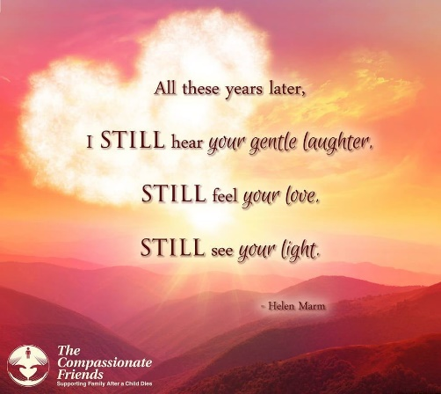

**Fall**

Will I ever see the leaves turn and wither without thinking of my son’s last days? On the first day of Fall each year my heart aches. Yes, there IS such a physical thing as heartache. It feels like the chest cavity is too small. It hurts.

When I look at the world, the wispy fall clouds look like the sky has a furrowed brow, and occasionally it puckers up and cries with me. The sun is so innocent, so naïve. It casts its rosy glow on every object, oblivious to the gray pain just around the corner. The trees begin to cry their dead leaves onto the ground and stretch their empty arms heavenward (like me), asking “WHY?”

And then I think of my own naïveté five years ago with bittersweet memory. I can’t say I was carefree, but I never knew the terrible aching grief of losing a loved one. For many months after my son died, I longed to escape back to the days before I felt the pain. Now I know that going back is more painful than facing the NOW.

All the other months I live a relatively happy and healed existence, but beginning with that first day that’s truly “autumn” … My heart hurts, my brow furrows, my eyes cry, and even though the warm sun shines on me, my arms feel empty, and they are raised to the heavens asking, “WHY?”

Hurry up, Fall, and move on by. Even the dead of winter is preferable to the pain you bring me each year.

*--Donna Ellis, Kansas City, MO*

**The Death of the Young**

People ask: “Why do children or young people die, when they have lived so little?” How do you know that they have lived so little? This crude measure of yours is time, but life is not measured in time. This is just the same as to say, “Why is this poem, this picture, this piece of music so short? Why was it broken off and not drawn out to the size of the longest speech, or piece of music, or the largest picture?”

As the measure of length is inapplicable to the meaning (or greatness) of works of art or poetry, so—even more, evidently—it is inapplicable to life. How do you know what inner growth this soul accomplished in its short span, and what influence it had on others?

*–Leo Tolstoy*

**Any Child’s Death Diminishes Me**

What difference does it make whether a child is stillborn or dies after some years of life? She spoke of the lack of memories because her child was stillborn. He commented on the deep pain brought by those very memories which remind him of what he lost!

When it comes to a child’s death, does the type of death matter? Is a murder worse than an accident? Suicide worse than chronic illness? Teenage worse than older adult? Stillborn worse than teenage?

I’ve tried to be thankful that Jeanie wasn’t murdered, that she and those dear boys did not linger comatose or die from prolonged illness. I could not find thankfulness, though I have sought diligently for it within my deepest being!

The death of each child, whatever the age or circumstances, brings its own guilt and anger, its own despair and questioning.

Any child’s death diminishes the parents who love that child, and for those bereaved parents, that death is surely the worst, their grief the most severe! *--Robert F. Gloor*

**Seasons**

As the seasons change, so do the emotions.

As the bounty of spring volunteers its color, there is just something missing after the loss of a child.

The cheerful colors from

the beautiful flowers I love,

have lost their appeal to my senses.

I loved the smell of fresh cut grass

and the bloom of the trees as the leaves return only to provide a short release

from this fracture in my heart.

As the days grow longer and

the sun grows hotter, it only seems

to painfully remind me of my child

who lived for every season?

He loved the sun and was so tan.

And the fall was the time when we vacationed. We loved to travel.

Colorado and the wonders of the mountains. He loved the mountains.

I don’t know if I will ever be able

to go back.

As fall progresses and turns into winter, here come the holidays.

We loved Thanksgiving,

even though it was stressful to

accommodate everybody’s schedules.

Then Christmas.

I was so excited to get him the best present, something over the top (at least in my eyes).

I got such joy doing for him.

Now that he is gone (you know what I mean if you too have lost a child),

the special dates of the year now represent an empty seat at the table,

an empty spot in the pictures,

an empty space under the tree….

How could life be so cruel

to have taken our children?

After almost a year

I am not even close to an answer.

Only more questions—why, why, why…

I now have been through

all of the emotional seasons

and am still trying to find

some sunshine for my heart.

Some days there is sun and

some days there is rain,

but mostly the days are cloudy,

and as I look to the sky

(and I do every day)

I am still looking for that something

which will give me peace.

I want to do something every day of my life now to honor him.

I want him to look down and say,

“I am proud of you.”

I want to be a better person

and live a better life now too

so that I will always be that person

he always knew I was.

His Dad.

*--Mark Warren, So. Kansas City TCF, in memory of his son, Mark Jr*

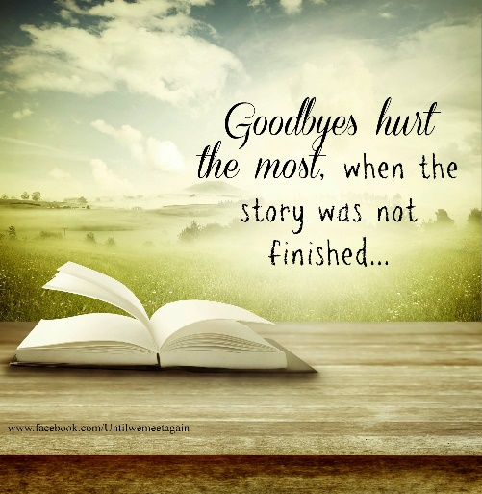

###### But Norman Rockwell Never Painted Me

At this time of year, it always seems

That I see the families of others’ dreams.

Everywhere I look, every ad I see

Shows the joyful reunions of family.

With the table laden, good times abound

While families reunited gather around.

But Rockwell never painted an empty chair

And a family mourning the one who’s not there.

A season that once was celebrated

Now makes us feel more isolated.

I need TCF so that I can see

That there are others just like me

Whose feelings about holidays are mixed, at best,

Whose strength of will is put to the test.

We’re loving those whom we still hold near,

But thoughts of one out of reach bring a tear.

Even now, amidst the love and gladness,

This time of year brings a certain sadness.

I no longer have the “average” family,

So that’s why Rockwell never painted me.

*--Kathy Hahn, TCF Lower Bucks County,PA*

**Ghost Story**

“Daddy, Daddy, come with me please.”

To others it’s only the wind in the trees,

but in the soft haze of dusk

when the mind runs free,

the ghost in the woods is calling to me.

He’s spoken often since we’ve been apart

in a voice heard not with ears but my heart,

Down familiar overgrown pathways

he leads me to the creek

where wood duck’s nest in the weeds.

“Over here. Over here.”

By the ghost I’m drawn into the thicket

where he once found a fawn, white spots

on brown in a thick bed of leaves.

Had he not shown me,

I would have believed it was bare.

“Look up, Daddy, look. It’s still there.”

The frayed end of the rope swing

high in the air dangles.

Unused since he left.

Just beyond, past the spring

and the meadow lies the pond.

“Come, come.”

Running ahead, he leads me there

to the sunken log in the corner

where he caught his first fish.

I stand, now alone, while darkness deepens,

then slowly head home,

hearing his voice fade

into the haunting call of the owl.

I stroll through the dark and with hope recall

how a few past times

before my walk was done,

I experienced something beyond belief,

as wholly engulfed by memories and love,

for a brief magic moment,

I and the ghost became one.

*--Richard Dew, in “Rachel’s Cry”*

**Second**

I used to be second to experience what life has to offer.

Second to walk.

Second to lose my first tooth.

Second to learn how to ride a bike.

Second to learn how to drive.

Things started changing

after your death.

First to graduate.

First to go off to college.

First to turn nineteen.

I’m sick of being first.

I just want to be second.

*--By Lisa Yoakum, sister of John*

*(7/26/88-10/13/06)*

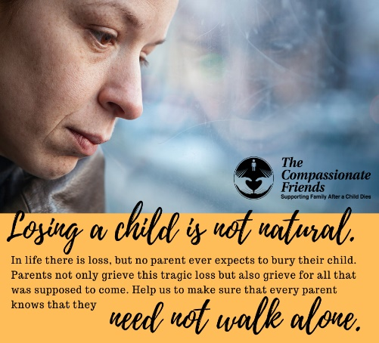

Autumn’s arrival signals

a season of richness, not regret

The bird dogs spend their night—or part of it—in the chairs we bought for ourselves to sit in. But sometime between 3:00 & 4:30 a.m. they are fully rested.

At that hollow hour, awakened by the urgent racket of their toenails clicking on the floor, I roll groaning from bed and follow them downstairs to let them out into the fenced back yard.

There is no memory afterward of sleep being interrupted. Immediately, then, as if no time had passed, the clock radio begins to sing its dismal little song.

The dogs, listening below the open bedroom window, hear the radio, and Pete, the vocal one, sets up an insistent yipping to notify me of their desire for breakfast.

But outside all is black. It still is night. The radio has come on by mistake. I look at the digital numbers on its face. There’s no mistake. The clock says 6:20 am, the usual time for the beginning of our day.

What has happened is that, in the sweet march of an uncommonly pleasant summer, we’d simply forgotten what it is like to rise in darkness. Then, in a strange and sudden way, one notices that the planet has tilted a fraction on its axis, and our world has changed.

I love the autumn, and always have. The sharpness of the mornings, the suddenness with which the golden afternoons soften into evening, the greater length of shadows, the wild asters in bloom on the roadside, the flame of sumac against a green hillside, the drift of leaves outside the window—those are the signatures of the season I live for.

Some people may see it as a time of things ending, a season of regret. But I feel only the satisfaction of things complete and others about to begin.

My country friends are busy bringing in their harvest, counting up the yield of their year’s labor.

When the first hard frost has burned the lush foliage brown, the dogs and I will be in the field. The orange and brown and white flash of them against a far wood line, as I trudge behind, will bring fresh again the memories of other years, other pups, other friends.

Then we’ll be into the holiday time, with families regathered and the table full and diets briefly put out of mind.

All that is the richness that autumn brings. And *[never having buried a child]* I’m at a loss to understand how anyone could find it melancholy. Would I like to be young again? Who would not? Would I like to be new at writing again, to feel that wonderful fear and excitement of the beginner? Absolutely.

Would I like the chance to spend some days again with the people in my life I’ve lost? Of course, I would.

But past is past. And now, in this turn of the year when I wake to find the morning has arrived in darkness, instead of looking backward, I imagine only what’s sure to be ahead.

*--C. W. Gusewelle*

Wings Take Flight

Feathered bodies pass demurely,

Webbed feet paddle furiously,

Perfect patterns forming in their Wake.

All is well, my friends the Geese;

I, like you, with poise and peace

Glide on the surface of this Grief.

If my feet stop, will I drown?

Will onlookers rush in from all around

As so they gawked at my little child?

Honk! Honk! I want to say

Make a noise! Do something

My feelings to betray.

Let not my feathers unruffled remain

While wrestling the waters

of boundless pain

That webbed foot could never

dare contain.

The water is cold…Could I be so bold?

Feathers unfold

For stories untold

As weeping, Wings take Flight.

I wrote this poem while on retreat after the death of my daughter. I was struggling with the vast deception of my outward composure—the graceful gliding through social circumstances—achieved only by “furious paddling” on the inside, as I grappled with the vast body of water that was my grief. Grief completely surrounded me; it was an entire lake, much larger than myself, in which I swam tirelessly in order to keep from drowning.

Eventually I remembered my wings. I remembered there is always the sky. Ultimately, this poem is about moving on in the midst of grief. Even as we remain weeping, we must, at some point, spread our wings—dripping with the waters of grief, our tears—and open ourselves to new flight, new stories of hope and healing in our lives. For a goose the water will always be there; thus, so the grief for me. But I have my wings too. And the sky.

*--Lisa DeBoer Tuggle, Dunlap, TN*

**Please help us help others. Make a LOVE GIFT today**. **Tax deductible Love Gifts may be sent to: TCF C/O Theresa Phillips 6200 Kentucky Ave, Raytown, MO 64133**

**Remember when you came to your first meeting, and someone was there who was a little farther down the road and gave you a hug or shared something that made you feel like you are not crazy. Well, if you are a little bit farther down the road, please feel free to come back to our meetings and help families that are just starting their grief journey.**

*Please visit our website at* [*www.easternjacksoncountytcf.org*](http://www.easternjacksoncountytcf.org)

*Find us on Facebook at* [*https://www.facebook.com/groups/1582699755290182*](https://www.facebook.com/groups/1582699755290182)

*We have several volunteers who write remembrance cards to families on birthdays and death dates. Just a reminder if you have an address change please email* [*phillipsplace@aol.com*](mailto:phillipsplace@aol.com) *or mail a note to TCF, C/O Theresa Phillips 6200 Kentucky Raytown, MO 64133 so the roster can be updated.*

*Please remember that you can give to The Compassionate Friends through your United Way pledge at work or as a single gift, but you MUST WRITE IT IN.*