 **Nov – Dec 2019**

**Chapter Leader: Theresa Phillips TCF National Headquarters**

# 24-Hour Help Line: (816)229-2640 PO Box 3696, Oak Brook, IL 60522

**Private Facebook Page: Eastern Jackson County TCF Website: www.compassionatefriends.org**

**Website: www.easternjacksoncounty tcf.org 630-990-0010**

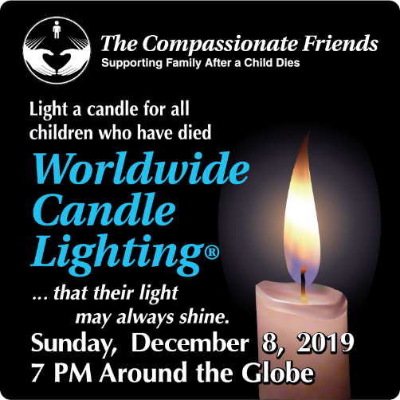

**WORLDWIDE CANDLE LIGHTING CEREMONY**

## December 8, 2019

Sponsored by:

The Eastern Jackson County (Independence) and

South Kansas City Chapter of

The Compassionate Friends

In memory of all children who have died, but will not be forgotten . . .

*that their light may always shine*

In loving memory of all children who are no longer with us, The Compassionate Friends extends an invitation for you, your family, and friends to join us and other bereaved families around the globe for the 19th annual Worldwide Candle Lighting.

### *Sunday December 8, 2019 at 7 pm*

#### At Walnut Gardens Community of Christ 19201 RD Mize Rd, Independence, MO

**Our Guest speaker is Chuck Findley.** He has been a part of writing two books with other fathers who have lost a child. He has been involved is starting dad’s group in Indianapolis and has now branched out across the country in cities such as Scottsdale, AZ, Humble, Texas, Northern CA (Bay Area) and recently here in Kansas City.

1. If you would like a picture button, come at 6:30 pm. Bring a picture on plain paper 2 ¼ to 2 ½ inches.

##### 2. Also bring a picture for the memory table

##### 3. A snack to share after the program

4. If desired, bring a gift for a needy child in memory of your child

5. Plus we will be having a raffle.

As candles are lit at 7 p.m. local time, bereaved families gather to honor their loved ones in a way that transcends all ethnic, cultural, religious and political boundaries. Believed to be the largest mass candle lighting on the globe, the ceremony creates a virtual 24-hour wave of light as it moves from time zone to time zone. Wherever you are at that time, we hope you will join us in this loving remembrance. A memorial message board will be available that day at [www.thecompassionatefriends.org](http://www.thecompassionatefriends.org). Please allow time for sign in and find a seat before 7pm.

In the event of inclement weather please watch your emails and the chapter website [www.easternjacksoncountytcf.org](http://www.easternjacksoncountytcf.org)

**I Give Thanks**

**For Time** - The time I had with Tim, time to grow and learn even when I’m no longer young, and time which will one day reunite me with my child.

**For Friends** - Those whom I’ve known that time has taken from me, those I cherish now, and those I’ve yet to meet.

**For Answered Prayers** - I asked for comfort and strength to face what I must face and You answered me - maybe not the way I wanted, but You always answered me.

**For Family** - And I find my family expanding with each day. I find relatives need not always be family, and family need not always be relatives. *Love makes families, not blood lines.*

**For the Children** - Those remaining-- mine and everyone else’s. And for the ones that remain only in memory.

**For Love** - Love that’s been given me so freely from hearts that were broken like mine, but still could offer me strength and hope.

For all of you, I give thanks.

*--Judy Dickey, TCF, Greenwood, IN*

**The Empty Chair**

I remember the first Thanksgiving after Tony was killed. I didn’t know how we could possibly get through that dinner with his empty chair.

The solution that occurred to me was to fill his chair with someone else--several someones. Grandpa came to spend the week; a newly widowed friend came for dinner, and so did her delightful young nephew and his bride, who had just moved to town. They brought the salad. And we were thankful--for each other, for the love among us, and for memories.

If this will be your first Thanksgiving, do something different. The pattern for your life has been broken. Break it some more! Have dinner at a different place, or with different people. Go away for the weekend. Be kind to yourself. You do not have it all, but you have something.

*--Ronnie Peterson*

**Candle in the Night**

I could not find her in the sky.

I did not see her ‘neath the sun.

But when the shadows darken,

And the endless day is done,

Like a candle in the night

She gleams upon my sight,

And her whispered name

Warms me in the flame.

Vicki...in my prayer

Holds and loves me there.

*--Earl Katz*

***Words from Sascha Wagner***

**The Other Season**

*Look to the season of your memories—  
it fills the weather of your life*

*with mildness.*

*It turns to laughter what your love remembers:*

*the sound of words, invented new for singing,*

*discovery of all-important secrets.*

*Look to the season of your memories—  
it sets an ordinary past to music.*

*It changes ordinary tears to treasure.*

*It gives your faded pictures shape*

*and color:*

*the touch of eyes, a walk in the foggy twilight.*

*Look to the season of your memories—*

*how rich you were and be how rich again.*

*Look to the season of your memories:*

*mourn and recall the Child you love,*

*you love—*

*until you lose yourself—*

*to find yourself*

***To the Dead Infants***

*They are gone*

*these young hearts*

*these flawless souls.*

*They are gone*

*and we must grieve*

*their loss—*

*we must remember.*

*But when we begin to live again,*

*then we can be*

*each one of us*

*a heritage of humanness*

*a memorial of hope*

*a sign of closer understanding*

*in their name*

*who are gone,*

*these young hearts*

*these flawless souls—*

*in their name*

*let our lives grow*

*The heart knows many songs*

*and sings them well.*

*The heart knows images*

*and sees them,*

*even when life is much too dark*

*to light the eyes.*

*The heart knows many songs*

*we cannot hear.*

*The heart is wise.*

***Traditions***

*Have you been taught*

*to cry without a sound*

*(the tears descending*

*like a cutting edge)?*

*Have you been taught*

*to smile beyond endurance*

*(your throat an aching*

*lock around your heart)?*

*Have you been taught*

*to owe the world your service*

*until your mind*

*seems not to be your own?*

*Do not consent.*

*Truth teaches other lessons:*

*grief needs to sob aloud;*

*grief does not want to smile;*

*grief wants to serve*

*your inner healing, first.*

***In Time…***

*When we grieve and hurt, we seem to*

*be more aware of everyone’s*

*shortcomings, mistakes and limitations.*

*When we grieve and hurt, we seem to be*

*less capable of forgiveness and understanding.*

*When we grieve and hurt, we must try*

*to realize that feelings of anger*

*and bitter frustration are natural.*

*We must also recognize that most of*

*this angry sensitivity is temporary.*

*In time, we will rediscover our ability to understand and forgive  
 many people,*

*not only others in the world around us, but also ourselves.*

*The important word here is “IN TIME”*

***Solace***

*In the smallest hour of your day,*

*when you are alone*

*with things remembered,*

*questions unanswered*

*and unfinished dreams, then:*

*give to yourself*

*the gifts of your kindness,*

*bring to yourself*

*the comforts of forgiving,*

*share with yourself*

*the mercy of your love.*

***Who Is to Say—***

*Love and death*

*are the most powerful events*

*in human experience.*

*Joy and grief*

*are the natural companions*

*of love and death*

*Who is to say*

*that we could have*

*love and joy*

*if we had not*

*death and grief?*

***Wish***

*I wish you gentle days*

*and quiet nights.*

*I wish you memories*

*to keep you strong.*

*I wish you time to smile*

*and time for song.*

*And then I wish you friends*

*to give you love,*

*when you are hurt and lost*

*and life is blind.*

*I wish you friends and love*

*and peace of mind.*

***Giving Thanks***

*I cannot hold your hands today,*

*I cannot see your smile.*

*I cannot hear your voices now,*

*my children, who are gone.*

*But I recall your faces still,*

*the songs, the talks, the sighs.*

*And story times and winter walks,*

*and sharing secret things.*

*I know you helped my mind to live*

*beyond your time with me.*

*You gave me clearer eyes to see,*

*you gave me finer ears to hear,*

*what living means,*

*what dying means,*

*my children, who are gone.*

*So here it is Thanksgiving Day,*

*and you are not with me.*

*And while I weep a mother’s tears,*

*I thank you for the gifts you were,*

*and all the gifts you gave to me,*

*my children, who are gone.*

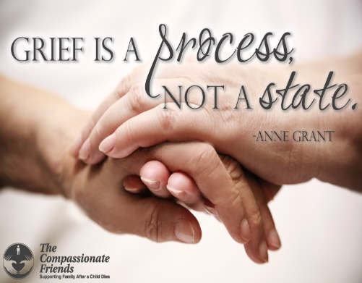

**The Perfect Circle**

I wish for all parents the peace that comes through the commitment to your own growth. As we turn to help others, we in turn are comforted and grow—the perfect circle.

*--Julie McGee, TCF, Louisville, KY*

**The Empty Chair**

There's an empty chair in our house and I am not sure what to do with it. It's been empty a long time, and though we've moved more than a few times since it became empty, we still haul it around with us. It's not a particularly classic chair or even a very pretty one, and it is empty all the time. Whenever we move, I never really know which room to put it in, but once it has found its place, I've noticed that it simply stays there. No one moves it, no one suggests putting it away. No one sits in it. It's just an empty chair.

We have been a military family for many generations, and we are used to having members of the family off in faraway places for what often turns out to be long periods of time. My father would sometimes be gone for up to a year, or even two. His chair was often empty at the table. My husband's military career took him away for many months at a time, and his chair was often empty. Then, when our daughter was commissioned in the military, we knew her chair would also be empty sometimes. So empty chairs at our house are not an uncommon thing, but this chair...this chair should never have been empty.

As the holidays approach, I am always faced with the task of deciding what to do with our empty chair. Should we put it away for the season? Should we decorate it, or should we just ignore it? One year we did decide to put it away, but even though it was an empty chair, it left an even bigger empty space when we moved it to another, less occupied place. How can that be? How can something that is empty leave a bigger empty space when it's gone?!

We've tried to ignore it, but its emptiness is very loud, and it is hard to miss an empty chair in a room filled with people sitting in all the other chairs. And even when we could manage to ignore it, others could not, and they always commented on it. An empty chair is not invisible.

Then, one year, we decided to simply include it in our holiday decorating scheme and that was the cause of some interesting discussions. Should we put a special holiday pillow in it? What about tossing a colorful quilt or afghan over the back! Should we put something in the chair, so it wasn't empty! Now that was a novel idea! But nothing we tried could fill the emptiness of that chair. It just sat silent like a sentinel, waiting for something...or someone.

It took us many years of living with that empty chair, day in and day out, to finally figure out what to do with it. When we serve our meals, those chairs that would have been occupied by the assigned person (yes, we do assigned seating at our house) can be filled by other family members or guests. You get to use the sterling silver napkin ring with that person's name on it, and if you are lucky, that person has not lost a knife or fork or spoon over the years, so you will have a complete place setting of silverware. You must endure listening to tales about the person whose chair you are occupying.

It makes for some lively conversations and that way, even though you may not be with us for this occasion, your presence is still in our life. That works for our empty chair as well. It is a military custom to always set a place at the table for those who are not with us at this time, but whose lives are still within our hearts. So, we have a place setting, complete with silverware (all 6 pieces), dishes, crystal goblet and napkin ring. Our empty chair is pulled up to the table and a single rose is placed on the plate, a symbol of everlasting love.

We join hands in thanksgiving, completing the circle with the empty chair within our family circle, for even though death may have come, love never goes away. That empty chair now represents all of us who ate not with us for this occasion but who live within our hearts forever. It is not a sad sight, because we know that empty chair represents a love we have known and shared, and with that gift, our family is forever blessed.

So, if your holiday table will have an empty chair this year, remember that it is not truly an empty space. That place is still occupied by the love and joy of the one who sat in it. Don't hide that chair away. You may not wish to bring it to the table as we do, but take time this holiday season to remember the laughter, the joy, the love, the light of those who are no longer within hug's teach, but whose love still fills us with gratitude. Join hands around your table, however small, and say a prayer of thanksgiving…for the love you have known and still hold deep within your heart. You are rich beyond measure for having had a chair fulfilled. Don't let death rob you of the heart space that love keeps.

No one has sat in our little empty chair for twenty-five years…until this season. The table is still set with a place for all of those who are not with us on this occasion, but the empty chair at our house has been filled with the tiny spirit of a new life as she found that chair to be, "just the right size, Grandma." We are a family circle, some chairs filled and others not, broken by death, but mended by love.

Darcie Sims Reprinted with permission to TCF by Bereavement Magazine Nov/Dec 2001 edition [www.bereavementmag.com](http://www.bereavementmag.com)

###### But Norman Rockwell Never Painted Me

At this time of year, it always seems

That I see the families of others’ dreams.

Everywhere I look, every ad I see

Shows the joyful reunions of family.

With the table laden, good times abound

While families reunited gather around.

But Rockwell never painted an empty chair

And a family mourning the one who’s not there.

A season that once was celebrated

Now makes us feel more isolated.

I need TCF so that I can see

That there are others just like me

Whose feelings about holidays are mixed, at best,

Whose strength of will is put to the test.

We’re loving those whom we still hold near,

But thoughts of one out of reach bring a tear.

Even now, amidst the love and gladness,

This time of year brings a certain sadness.

I no longer have the “average” family,

So that’s why Rockwell never painted me.

*--Kathy Hahn, TCF Lower Bucks County, PA*

Leaves are turning the shades of autumn,

Then falling, one by one, to the misted ground below.

Summer flowers have faded and died.

The sun hides behind dark and dreary clouds.

It is November again.

Was it so long ago that this month brought warm?

Thoughts of Thanksgiving together,

The smell of wood burning, walks in the nippy air.

This is the month you left us,

And all the warm glow of November went with you.

All that remains are the chrysanthemums

Planted in a special memorial garden for you,

Ready to burst into beautiful shades of yellow and orange.

They symbolize one more year without you,

But our LOVE has not diminished.

*--Pat Dodge, in memory of her son Scott, TCF Sacramento*

###### A Boy and His Tree

It was time. In an hour the November afternoon would be dark. With Baby Elizabeth in the stroller, we headed to our front lawn. Benjamin immediately began to run around, but my husband, David, seven-year-old Rachel and I stood beside the thin tree. Rachel held the order of ceremony that she had spent the afternoon writing. It was three pages of her own creation, the “service” for our family’s gathering that afternoon. Five members were visible to the human eye; the sixth member was held within our yearning hearts.

“We are very sad at this moment,” Rachel began to read from her printed page. “We think of the things we did together, and we think of the sad things that happened too, and it won’t be so hard. But we will still be a little sad in the heart.” Then she somberly passed the papers to my husband. She had written the next lines for him to read and they ended with, “It’s going to be hard to keep the tears away, but we will still dig up this tree, even if it hurts.”

And that was our reason for the ceremony. It was time to dig up the thin maple that died last fall and, like Daniel, did not bloom in the spring. It wasn’t just any old maple tree. The tree had so much significance, and that was why it had taken us all of spring and summer before we were ready to uproot it. Without leaves, it spent months in the front lawn. I was prepared to tell neighbors why we couldn’t dig it out of the ground, but no one asked why we kept a dead tree in our yard. Could they have known it was the very tree we planted three weeks after Daniel’s birth? Did they realize it died only a few months before our four-year-old son?

I had looked at that tree many times since Daniel left us, remembering how he played by it, rode his Cozy Coupe under it and ran around it. Just the other night when looking through the hundreds of pictures we have of him, I found one with him at age three in a hat and funny sunglasses, holding the tree. Never in our wildest dreams had we known both boy and tree would be gone in the same year. When the lines of the memories of Daniel had all been read, David dug up the dead tree. “Good-bye, Daniel,” I said within my heart. It was as though a part of Daniel was again being taken from me. It was the same feeling of “good-bye” as I had felt when the men from the Vietnam Veterans had come to take the old, plaid sofa. Daniel had lived on that sofa during his last months. There he’d eaten cereal, watched videos, looked at books & thrown up. David cut a few branches from the tree, and Rachel announced we could make a cross out of them to place in the little memorial garden we have by the side of the house. Then, with David placing the maple over his shoulder, he and Rachel began to walk toward the nearby woods. Daniel had enjoyed the woods so much, and we knew it was a fitting place to carry his tree.

I was reminded of the time he and Rachel had ventured in there alone and were rescued by the brother of one of our neighbors. And there was the time Rachel, Daniel and I, along with one of Daniel’s friends, went for a walk in the woods and got lost. It was raining when we finally found our way out. We had no idea where we were, so we asked directions to get home. A kind, elderly man offered to drive us home. The kids had been excited about riding in his Oldsmobile, while I just felt foolish for getting lost.

When he returned from taking the tree to the woods, David placed a stake in the ground where the tree had been. This was to mark where we wanted the next tree to be planted. The local nursery was to come that week with a new tree, given to us by friends who wanted to do something in Daniel’s memory.

What a surge of joy I felt when I looked out the window the next day to see the newly planted tree! We had chosen a gentle and drooping weeping willow, because there was such significance in its very name and stature. It would be a reminder to others of our weeping spirits over the loss of our precious son, and to us, we would watch this tree grow and flourish, as our memories and love do for Daniel.

*--By Alice J. Wisler*

Grief can change your outlook. You don’t ever forget the shock, the sadness, and the pain. But I do not believe that grief changes who you are. Grief, if you let it, will reveal who you are. It can reveal depths that you did not know you had. The startling weight of grief can burst any bubble of complacency in how you live your life, and help you to live up to the values you espouse.

--Prince William, Duke of Cambridge, *October’s edition of Reader’s Digest*

**Low-Fat, Lite Holidays**

*By Darcie D. Sims, PhD, CHT, CT, GMS, bereaved mother*

I’m tired of low fat! I’m tired of fat-free. I’m tired of thinking rice cakes are good; they’re not the same as Oreos! I’m tired of trying to be creative in my thinking, my eating, my living, and I’m tired of dreading the holidays. In fact, I’m just plain tired.

Can anyone stop the holidays please? Can anyone find a fat substitute that really tastes like mom’s pumpkin pie? Can anyone figure out a cure for the pain of these memories? Probably not. So, as long as we are stuck with the approaching holidays and as long as we remain determined to be healthy and keep up the good low-fat fight, what can we do to turn this season of despair into a season of hope? Where are the beacons of light?

**Be patient with yourself.** Know that hardly anyone is as happy as you think they might be. We all have our hurts to hide. We are always in a hurry. We want things to be better now. Do what you can this season and let that be enough.

**Be realistic.** It will hurt, especially if there is an empty chair at the table. Don’t try to block bad moments. Be ready for them. Lay in a supply of tissues (a roll of toilet paper is more efficient). Anticipation is often far worse than reality. Let those hurting moments come, deal with them and let them go. Leave the word “ought” out of this holiday.

**Plan ahead.** Grieving people often experience a lack of concentration. Make lists. Prioritize everything. Decide what is really important. (Breathing and potty time rank right up there!)

**Redefine expectations.** Be honest in what you expect to be able to do. We live in a world of ought’s and should's and suffer from guilt because we cannot meet our own expectations.

**Be kind and gentle to yourself.** Figure out what you should do, balance it against what you are capable of doing, and then compromise. Forgive yourself for living when your child died.

**Listen to yourself.** Find the quiet space within where all answers live. As you become aware of your needs, tell family members and friends. Keep some traditions; choose which ones. Don’t toss out everything this year. You can always try changing a routine. Try whatever pops into your head. You can always scrap it if it doesn’t work.

**Take care of yourself physically.** Eat right. Exercise (or at least watch someone else). Jog your memory!

**Hold on to your purse and charge cards.** You can’t buy away your grief, although you might be tempted to try.

**Screen all holiday activities:**

Will it be the holiday without it? Why do you do this activity? Tradition, habit, obligation? Do you have to do this, or can others do it for you? Do you like doing it? How could this activity be done differently?

**Give yourself the gift of emotions.** Put the motion back into the emotions. Toss a nerf ball when you’re angry, pound a pillow. Go outside and yell while you shovel snow. Find a way to express the intensity of your feelings in a personally non-destructive way.

**Buy a gift for your child.** Give it away to someone who would otherwise not have a gift. It is the giving, the exchanging of love that we miss. When you share love, it grows.

**Hang the stockings, place a wreath on the grave.** Do whatever feels right for you and your family.

**Share your holidays.** Ride the ferry, visit a soup kitchen or nursing home, spend an evening at the bus station. There are lots of lonely people who could use your love and caring.

**Work at lifting depression.** Take responsibility for yourself. We cannot wait for someone else to wrap up some joy and give it to us. We have to do that for ourselves. Think of things you enjoy and give yourself a treat.

**Understand that heartaches will be unpacked.** As you sift through the decorations, appreciate the warm, loving memories of each piece. Don’t deny yourself the gift of healing tears.

**Ask for help.** Make a help-on-a-stick sign and stand on the porch, waving it. Someone will notice (but they may not stop). Just because you ask for help doesn’t guarantee you’ll get some; but if you never ask, no one will ever know how much you might need help or even a hug.

**Learn to look for joy in the moment.** Learn to celebrate what you do have instead of making mental lists of what you’re missing. Change the way you look at things.

**Light a special candle.** Not in memory of a death, but in celebration of a life and a love shared! Never forget that once someone loved us and we loved back. NO ONE can deny that.

**Live through the hurt.** Joy can return to warm your heart. I’m not going to let yesterday use up today. If I have a terrific memory to cherish, I’ll enjoy it. I will not allow pain or fear or sadness to ruin the entire season. It may not be the same as before we became bereaved; but whatever it is can be something, and that just may be the beacon of hope in this season of despair.

Grab the fruitcake and the low-fat turkey and get moving to the rhythms of this holiday season—the season where love and memory might lighten the heart and chase the gloom. Skip the fat, shed the tears, light the candle, and find the light. Make this holiday season full of light and love.

**The New Year**

After the holidays, we will be off on another 365. Some of you, I know, wonder if you can make it. That’s such an enormous amount of time to contemplate all at once, isn’t it? You may have some of your “firsts” coming in the months ahead, and the normal impulse seems to be to lump all those days together and dread them concurrently, like a prisoner serving several life sentences.

It’s possible to do it that way, but that’s the hard way. Getting through this day may take all the energy you can muster. Why try to handle March or May or July (or whenever your special days are) now? You can’t really, and by trying, you end up only defeating yourself in your effort to effectively survive *this* day. When this day is past, March or May or July will still be there, trying to defeat your tomorrow—but only if you let them!

Get past this day--and tomorrow and tomorrow and tomorrow. By the time March, May or July gets here you’ll have improved your coping skills. You can better handle your special days with more practice. I encourage you to know you can and will be better. Use this New Year to work toward that end.

*—Mary Cleckley, Atlanta, GA*

**Tradition, Tradition, Tradition**

Even in normal times, tradition isn’t always what it is cracked up to be, and sometimes “tradition” gets in the way of sanity. Often, we cling to tradition because it’s easier, we don’t want to offend others, we don’t want to be embarrassed, or we don’t know what else to do. When you are a grieving parent, giving in to tradition can drive you over the edge.

I found myself in the “tradition predicament” regarding putting up a tree the first Christmas holiday after my son, Chad, died. I didn’t want, need or have the energy to put up a tree. Yet other family members wanted a tree, and they wanted it as it always had been: big, bright, and decorated with ornaments they had purchased or made through the years. What eventually took place changed our holiday forever, and it has been a good thing for everyone involved.

I don’t remember the exact circumstances of how our “new tradition” came into being that first year, but I do remember frustration, tears, and upset people. I also remember my daughter saying to me it was her Christmas too, and *she needed a tree.* It was her older brother—the one she remembered getting up with every Christmas morning when she was little—who was dead, and she had to have something so she could deal with the emptiness. So, she came up with a plan. She and her father would go find the tree, and she would take care of the decorations all by herself.

That was ten Christmases ago, and this year, once again, my husband and daughter will leave early in the morning a week before Christmas to hunt for a tree, just the two of them. When they come home, I will prepare breakfast while they get the tree in the holder and move the furniture. We will sit down together and enjoy our meal, and then my husband and I will leave for several hours. During that time, we will do whatever we feel like doing. We have gone to the cemetery, taken walks, gone to the bookstore, visited friends, etc. When we return, my daughter will have decorated our Christmas tree and the whole house!

Every year the tree has been different, limited only by my daughter’s imagination and the budget we keep her on. She didn’t use our regular ornaments for a while, and when she did, she told me ahead of time and said how meaningful it was for her to be the one who put Chad’s ornaments back on the tree. We have continued this “new tradition” to this day.

Now I find angel ornaments to put on the tree to honor our missing angel, and—along with my husband, sons and family—enjoy my daughter’s traditional tribute to her brother. This “changing tradition” has been so healing. Our family has had the brightness and beauty that a lighted tree can provide, and I have been able to save my energy for other things I wanted to do.

During the next few weeks, I hope you will make the activities of the season as stress-free as you can. I hope that you will feel free to experiment with new traditions, knowing there is no “right way” to go through this season—only “your way.” I hope that you will remember Christmas is only one day, and that the time leading up to it will probably be more difficult than the actual day. And finally, I hope for peace in your hearts, if not today then tomorrow or the tomorrow after, or the tomorrow after that. Take care.…

*--Sue Anderson*

**

**Coping with Grief:**

**Winter Blues**

When the weather gets colder and the days get shorter, we often find ourselves feeling low. Some people call this the Winter Blues. When you are grieving, those blues can feel overwhelming. Grief itself *is* hard to cope with, and cold winds and dark nights can make those feelings seem more intense. Here are a few ideas that may help you cope with the Winter Blues:

Winter only lasts a few months. Use this *time to reflect* on your relationship with the person who died. Sometimes in our efforts to deny our loss, we rob ourselves of precious memories.

*Reach out to friends or family* when you can. Often our isolation is worse because we do not allow ourselves time with others. You are not alone. There are many other people going through a similar experience. Although your relationship with your loved one is special, other people can understand. Take the risk to ask someone over for coffee or tea. Share with them.

Take time to look through picture albums. Gather family to *share stories* when holidays are over, and the pressure is off. Make a new tradition during the dreary months of winter for family to gather for an evening of remembering. Maybe other people are feeling the same way and are afraid to talk about it.

Try a *grief support group*. Sometimes all we need is to know other people hear us and understand. A group can help you to know you are normal.

*Read:* favorite stories, comedies, novels, or information about grief to understand your own reactions better. Somehow reading about topics helps us know we are not alone. You can find grief materials in your local library or hospice office.

*Take good care of yourself.* Eat right, rest and pamper your body. This goes for any season. Your body is under a tremendous amount of stress in adjusting to this loss.

Since grief affects us physically, paying attention to our bodies is important. Whether you prefer to do things alone or with others, *physical activity* helps. Taking a walk, doing simple aerobics, indoor swimming, playing racquetball or other activities can help you keep your body ready for the continued adjustment to loss. Feeling better physically can make a difference.

If you feel sad and *need to cry*, know that this is a normal reaction. You are not weak if you need to show your emotions.

*Write a letter to your loved one*. Sometimes we need to communicate with them. Going to the cemetery is okay and normal. If the weather prevents that, a letter can be very helpful.

Remember that you will survive this loss. The pain and ache can seem like it will last forever. The intensity will lessen in time, although you will always remember your loved one. Time does not necessarily “heal” all wounds, but it can help us adjust to the change. Take it minute by minute…then day by day.

*--Lifted with love from the Sugar Land-Southwest*  *Houston TCF Newsletter.*

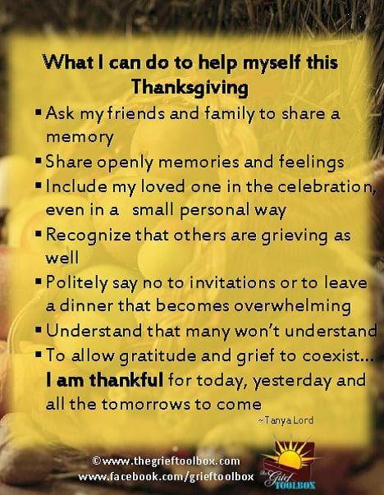

The good that we have los**t** must be kept alive and acknowledged; and so we give the dead their just tribute by the simple act of conscious memory: we call them back to tell them that their lives, however short, were not wasted, that life itself is not a waste, that part of our life is their living on among us.

This is not a recipe for painlessness, tranquility, or evading the fact of death....For me it is a way of being able to face what happened, to look into the flames in which my children’s lives were extinguished and say: All is not lost. It is a way of telling them that I still love them, that I owe my capacity for love to them; and that what I learned about loving from them is what has enabled me to survive.

*--John Tittensor*

**On a Night in December**

As days moved on towards winter

and trees were going bare,

we were faced with shopping malls

where carols filled the air.

And thoughts all turned to loved ones,

those present, and those not.

For us, whose lives were drained of light, it was solace that we sought.

And so, began a journey

of candles round the earth

bringing light to darkness

and honoring the worth

of children held so dear to us

but never to grow old,

whose lives filled our life tapestries,

with threads of finest gold.

Now we gather on this night

and watch the candles burn,

see their pictures, say their names

one by one, in turn.

And our children, brothers, sisters,

for whom we gather here,

let us know, in the candles glow,

that they are always near.

Their light will still surround us;

their love will always flow.

As we leave may we remember

that this is ever so.

*by Genesse Bourdeau Gentry*.

**On Hanukkah**

The Jewish winter festival of Hanukkah is about light, as befits a holiday that is timed to arrive sometime close to the winter solstice, the shortest, darkest time of the year. My memories of Hanukkah have to do with light as well— lighting candles in the menorah, the nine-branched candelabra which is both the symbol and the essential instrument of Hanukkah.

As luck would have it, both of our children were born in mid-November. Each was a babe in his or her mother’s arms when we first introduced them to the Hanukkah rituals, and we have photos in our family album of their fascination with the flickering candle flames.

Virtually every Jewish home has a menorah, to use once a year at Hanukkah time. We own several. We have an inexpensive tin one my wife and I used when we were in college and a lovely silver one given to us by members of my former congregation. One that has special meaning for me consists of nine empty wooden spools of thread glued to a board and spray-painted gold. Our son made it in nursery school. This was our son Aaron, who died when he was 14, and whose death prompted me to write *When Bad Things Happen to Good People.*

We can all be artists like that. We can take things of no apparent value and transform them. We can transform tragedy into a lesson in courage and compassion. Each December, when we pause at the darkest time of the year to light first one, then two, and finally eight Hanukkah candles, I am reminded of that lesson and my soul is warmed.

*--By Rabbi Harold Kushner*

**The Island of Misfit Parents**

In the Christmas animation “Rudolph the Red Nosed Reindeer,” Rudolph and his friends go to an island full of “misfit toys.” The toys are stuck there because they are different. The choo-choo train has square wheels, and the jack-in-the-box doesn’t have a spring. These toys are broken and left alone with no hope. As a bereaved parent, those have been my feelings exactly. For many years I too could not see beyond my island.

Eventually Rudolph returns safely to the North Pole. He tells Santa about the island and the broken toys. Santa goes to the island with his elves, and the toys are repaired. They don’t look all shiny and bright like new toys, but they do have hope beyond the island now.

Had I written this article prior to this year, I’d have stopped at the fact that the toys were broken and saw no hope. For most bereaved parents, that is quite true for some length of time. Now my ending tells me (and you) that there is hope beyond our island. We won’t be shiny and brand new, for we all have gone through many changes. But after much time for repair, we can experience the feeling of “hope” once more.

Holiday Blessings.

*--By Linda M. Trimmer, York, PA*

*.*

MC900354113[1]

**We Can Make It**

During the holiday season, both Christians and Jews light candles in celebration of their respective faiths. As they do so, even the darkest rooms become warm and bright from the glow of a candle. Then we can ask ourselves, how powerful or sinister can the darkness be if it can be overcome by the light of one little candle?

There is then a message in this for all of us. When the darkness seems to overwhelm us--and it can be a mental and spiritual darkness as well as the darkness of a winter night --we need to be reminded that it is powerless to withstand the smallest bit of illumination.

So, as the world grows colder and darker during these winter months, we as bereaved parents must do what people of many faiths have been taught to do at this season. Light a candle in someone’s life to make the darkness and fears flee. A little bit of light is all that most of us need, but oh we need that little bit so badly.

*--Bettye & Sam Rosenberg, Louisville, KY*

When we walk to the edge of all the light we have

When we walk to the edge of all the light we have

and take that step into the darkness of the unknown,

we must believe that one of two things will happen--There will be something solid for us to stand on,

or we will be taught how to fly.

*--Patrick Overton*

**Speaking Love**

Thoughtful mornings in November;

winter gray and chill at twilight.

Soon there will be colored candles.

Soon there will be celebration.

Do not force your heart from sorrow

at this time of happy splendor;

this is also time for speaking

love to dead and silent children.

*--Sascha Wagner*



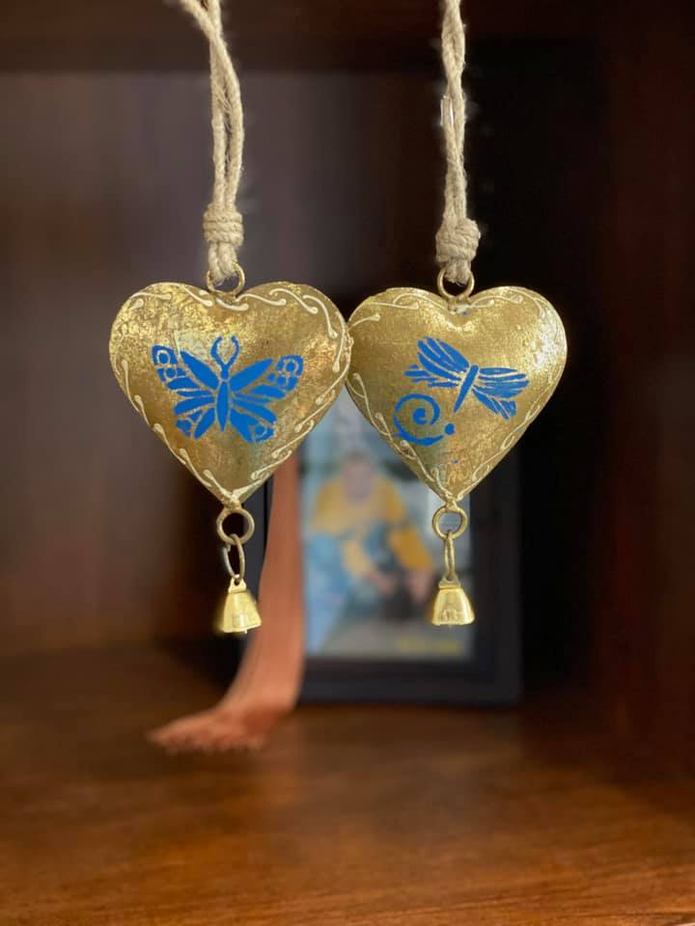

**Ring Your Bell as One**

Bells ring for endings and beginnings,  
But a “heart bell” is never ending.

This bell will in us forever ring,  
A tender sound only love can bring.

If your heart bears the weight of this bell,  
It rings within but you may not tell.

Others hear your “ring” but don’t discuss,  
Compassionate Friends rings hope for us.

We are ONE not different entities,  
All searching for broken heart remedies.

Ring hope’s story and never be done,  
Together we’ll help those yet to come.

Some have lost loved ones but yet don’t know,  
We’re here to teach how to make hope grow.

Some have no loss but life soon will spin  
To a club that we were all thrown in.

Never stop ringing your bell of love,  
For those with a loved one deprived of.

Now let’s all ring our bells together as one!

Tony’s Mom  
Debbie Rambis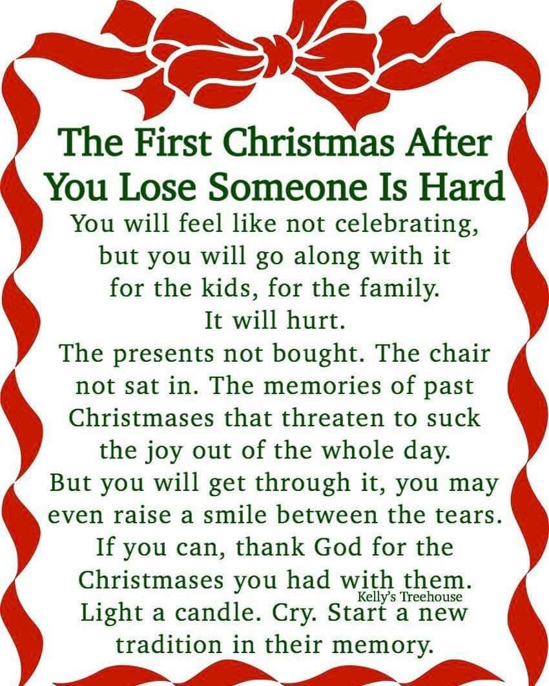

**A Holiday Letter to Family and Friends**

Thank you for not expecting too much from us this holiday season.

The absence of our child when the "whole family" gathers seems to

accentuate our incomplete family. It is difficult to cope with the

"spirit" of the holidays on the radio, TV, in the newspapers and

stores. We will need the patience and understanding of our family

and friends to help us through the holidays as best we can.

Our family traditions may be too painful for us to continue this year.

We may want to change the way we spend Thanksgiving, Christmas,

or Hanukkah. Please understand this and maybe sometime in the

future we will have these traditions again.

Whatever our thoughts are for coping with the day, please take our

feelings into consideration when you make your plans. Please allow

us to talk about our child, if we feel a need. Perhaps the single most

helpful thing you can do for us is to include our child in the holidays.

We want to hear his/her name, to have you recall fond memories of

their lives, to know that you, too, are feeling their absence and

remembering them with love.

As we work through our grief, we will need your patience and

support, especially during these holiday times and the "special" days

throughout the year.

Thank you for not expecting too much from us this holiday season.

Love, a bereaved parent/family.

Marge Henning

TCF West Orange and Madison, WI

**To Start a New Year**

If I can concentrate

On the moral and spiritual

Side of the holidays

I can make it through.

If I can absorb

The love and warmth

That was the beginning

I can give love back.

If I can share

The grief and the love

That is in me

Through these holidays

I can start a new year.

*—Tom Spray, TCF, Ventura County, CA*

**Holiday Thoughts**

For those who think that Christmas and Hanukah

are just nice days to give and get presents,

bereaved parents have another message.

Mixed with the joy is the knowledge of sadness.

With the hope of birth comes the threat of death.

We should not try to cover up our sadness in front of people, for

we have a lesson to teach them.

But the holidays have a lesson for us, too.

Yes, there is death.

Yes, there is great bitterness in life.

There is darkness.

But there is hope.

There is birth.

There is light.

In a society which works so hard to deny death,

perhaps only bereaved parents and a few others can truly

understand the depths of these holidays.

--Dennis Klass TCF St. Louis, MO

**Remember when you came to your first meeting and someone was there who was a little farther down the road and gave you a hug or shared something that made you feel like you are not crazy. Well if you are a little bit farther down the road please feel free to come back to our meetings and help families that are just starting their grief journey.**

# Love Gifts

**Please help us help others. Make a LOVE GIFT today**. **Tax deductible Love Gifts may be sent to: TCF C/O Theresa Phillips 6200 Kentucky Ave, Raytown, MO 64133**

*For Remembrance dates please visit our website at* [*www.easternjacksoncountytcf.org*](http://www.easternjacksoncountytcf.org)

*Find us on Facebook at* [*https://www.facebook.com/groups/1582699755290182*](https://www.facebook.com/groups/1582699755290182)

*We have several volunteers who write remembrance cards to families on birthdays and death dates. Just a reminder if you have an address change please email* [*phillipsplace@aol.com*](mailto:phillipsplace@aol.com) *or mail a note to TCF, C/O Theresa Phillips 6200 Kentucky Raytown, MO 64133 so the roster can be updated.*

*Please remember that you can give to The Compassionate Friends through your United Way pledge at work or as a single gift, but you MUST WRITE IT IN.*