Nov-Dec 2017
Chapter Leader: Theresa Phillips TCF National Headquarters

24-Hour Help Line: (816)229-2640 PO Box 3696, Oak Brook, IL 60522
Private Facebook Page: Eastern Jackson County TCF Website: www.compassionatefriends.org
Website: www.easternjacksoncounty tcf.org 630-990-0010

INCLUDEPICTURE "https://www.compassionatefriends.org/wp-content/uploads/2017/08/WCL-2017-CMYK.png" \* MERGEFORMATINET INCLUDEPICTURE "https://www.compassionatefriends.org/wp-content/uploads/2017/08/WCL-2017-CMYK.png" \* MERGEFORMATINET INCLUDEPICTURE "https://www.compassionatefriends.org/wp-content/uploads/2017/08/WCL-2017-CMYK.png" \* MERGEFORMATINET INCLUDEPICTURE "https://www.compassionatefriends.org/wp-content/uploads/2017/08/WCL-2017-CMYK.png" \* MERGEFORMATINET INCLUDEPICTURE "https://www.compassionatefriends.org/wp-content/uploads/2017/08/WCL-2017-CMYK.png" \* MERGEFORMATINET 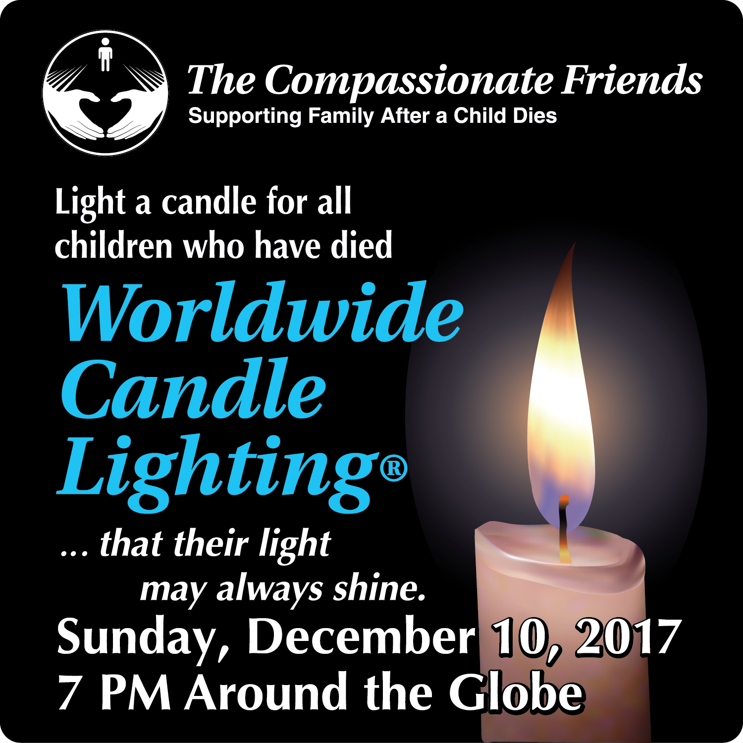
WORLDWIDE CANDLE LIGHTING CEREMONY
Sponsored by:
The Eastern Jackson County (Independence) and
South Kansas City Chapter of

The Compassionate Friends

Sunday,

December 10, 2017 at 7 pm

At Walnut Gardens Community of Christ,19201 RD Mize Rd, Independence, MO

In memory of all children who have died, but will not be forgotten . . .

that their light may always shine

In loving memory of all children who are no longer with us, The Compassionate Friends extends an invitation for you, your family, and friends to join us and other bereaved families around the globe for the 17th annual Worldwide Candle Lighting.
Items to bring:

1. If you would like a picture button, come at 6:30 pm. Bring a picture on plain paper: 2 ¼ to 2 ½ inches

2. Also bring a picture for the memory table

3. A snack to share after the program

4. If desired, bring a gift for a needy child in memory of your child
5. Plus we will be having a raffle.

As candles are lit at 7 p.m. local time, bereaved families gather to honor their loved ones in a way that transcends all ethnic, cultural, religious and political boundaries. Believed to be the largest mass candle lighting on the globe, the ceremony creates a virtual 24-hour wave of light as it moves from time zone to time zone. Wherever you are at that time, we hope you will join us in this loving remembrance. A memorial message board will be available that day at www.thecompassionatefriends.org.

November Again
November again, almost winter.
Muted world outside, faded red, misty yellow—
fog in the morning.
Even the hardest wind
seems kind enough,
because we know,
we know that stormy blades
lie waiting.
November again, almost winter.
Gently the heart reaches
for the awareness of things to come.
Holidays, so we call them.
Gently, the heart turns to Christmas.
Songs everywhere. And Lights.
Gently the heart must remember
the things gone by,
the time gone by,
the child gone by.
November again.
--Sascha Wagner

The heart knows many songs
and sings them well.
The heart knows images
and sees them,
even when life is much too dark
to light the eyes.
The heart knows many songs
we cannot hear.
The heart is wise.

Speaking Love
Thoughtful mornings in November;
winter gray and chill at twilight.
Soon there will be colored candles.
Soon there will be celebration.
Do not force your heart from sorrow
at this time of happy splendor;
this is also time for speaking
love to dead and silent children.
--Sascha Wagner
I Give Thanks
For Time - The time I had with Tim, time to grow and learn even when I’m no longer young, and time which will one day reunite me with my child.
For Friends - Those whom I’ve known that time has taken from me, those I cherish now, and those I’ve yet to meet.
For Answered Prayers - I asked for comfort and strength to face what I must face, and You answered me - maybe not the way I wanted, but You always answered me.
For Family - And I find my family expanding with each day. I find relatives need not always be family, and family need not always be relatives. Love makes families, not blood lines.
For the Children - Those remaining-- mine and everyone else’s. And for the ones that remain only in memory.
For Love - Love that’s been given me so freely from hearts that were broken like mine, but still could offer me strength and hope.
For all of you, I give thanks.
--Judy Dickey, TCF, Greenwood, IN
Low-Fat, Lite Holidays
By Darcie D. Sims, PhD, CHT, CT, GMS, bereaved mother
I’m tired of low fat! I’m tired of fat-free. I’m tired of thinking rice cakes are good; they’re not the same as Oreos! I’m tired of trying to be creative in my thinking, my eating, my living, and I’m tired of dreading the holidays. In fact, I’m just plain tired.
Can anyone stop the holidays please? Can anyone find a fat substitute that really tastes like mom’s pumpkin pie? Can anyone figure out a cure for the pain of these memories? Probably not. So, as long as we are stuck with the approaching holidays and as long as we remain determined to be healthy and keep up the good low-fat fight, what can we do to turn this season of despair into a season of hope? Where are the beacons of light?
Be patient with yourself. Know that hardly anyone is as happy as you think they might be. We all have our hurts to hide. We are always in a hurry. We want things to be better now. Do what you can this season and let that be enough.
Be realistic. It will hurt, especially if there is an empty chair at the table. Don’t try to block bad moments. Be ready for them. Lay in a supply of tissues (a roll of toilet paper is more efficient). Anticipation is often far worse than reality. Let those hurting moments come, deal with them and let them go. Leave the word “ought” out of this holiday.
Plan ahead. Grieving people often experience a lack of concentration. Make lists. Prioritize everything. Decide what is really important. (Breathing and potty time rank right up there!)
Redefine expectations. Be honest in what you expect to be able to do. We live in a world of ought’s and should's and suffer from guilt because we cannot meet our own expectations.
Be kind and gentle to yourself. Figure out what you should do, balance it against what you are capable of doing, and then compromise. Forgive yourself for living when your child died.
Listen to yourself. Find the quiet space within where all answers live. As you become aware of your needs, tell family members and friends. Keep some traditions; choose which ones. Don’t toss out everything this year. You can always try changing a routine. Try whatever pops into your head. You can always scrap it if it doesn’t work.
Take care of yourself physically. Eat right. Exercise (or at least watch someone else). Jog your memory!
Hold on to your purse and charge cards. You can’t buy away your grief, although you might be tempted to try.
Screen all holiday activities:
Will it be the holiday without it? Why do you do this activity? Tradition, habit, obligation? Do you have to do this, or can others do it for you? Do you like doing it? How could this activity be done differently?
Give yourself the gift of emotions. Put the motion back into the emotions. Toss a nerf ball when you’re angry, pound a pillow. Go outside and yell while you shovel snow. Find a way to express the intensity of your feelings in a personally nondestructive way.
Buy a gift for your child. Give it away to someone who would otherwise not have a gift. It is the giving, the exchanging of love that we miss. When you share love, it grows.
Hang the stockings, place a wreath on the grave. Do whatever feels right for you and your family.
Share your holidays. Ride the ferry, visit a soup kitchen or nursing home, spend an evening at the bus station. There are lots of lonely people who could use your love and caring.
Work at lifting depression. Take responsibility for yourself. We cannot wait for someone else to wrap up some joy and give it to us. We have to do that for ourselves. Think of things you enjoy and give yourself a treat.
Understand that heartaches will be unpacked. As you sift through the decorations, appreciate the warm, loving memories of each piece. Don’t deny yourself the gift of healing tears.
Ask for help. Make a help-on-a-stick sign and stand on the porch, waving it. Someone will notice (but they may not stop). Just because you ask for help doesn’t guarantee you’ll get some; but if you never ask, no one will ever know how much you might need help or even a hug.
Learn to look for joy in the moment. Learn to celebrate what you do have instead of making mental lists of what you’re missing. Change the way you look at things.
Light a special candle. Not in memory of a death, but in celebration of a life and a love shared! Never forget that once someone loved us and we loved back. NO ONE can deny that.
Live through the hurt. Joy can return to warm your heart. I’m not going to let yesterday use up today. If I have a terrific memory to cherish, I’ll enjoy it. I will not allow pain or fear or sadness to ruin the entire season. It may not be the same as before we became bereaved; but whatever it is can be something, and that just may be the beacon of hope in this season of despair.
Grab the fruitcake and the low-fat turkey and get moving to the rhythms of this holiday season—the season where love and memory might lighten the heart and chase the gloom. Skip the fat, shed the tears, light the candle, and find the light. Make this holiday season full of light and love.



The Other Season
Look to the season of your memories—
it fills the weather of your life
with mildness.
It turns to laughter what your love remembers:
the sound of words, invented new for singing,
discovery of all-important secrets.
Look to the season of your memories—
it sets an ordinary past to music.
It changes ordinary tears to treasure.
It gives your faded pictures shape
and color:
the touch of eyes, a walk in foggy twilight.
Look to the season of your memories—
how rich you were, and be how rich again.
Look to the season of your memories:
mourn and recall the Child you love,
you love—
until you lose yourself—
to find yourself

The Empty Chair
I remember the first Thanksgiving after Tony was killed. I didn’t know how we could possibly get through that dinner with his empty chair.
The solution that occurred to me was to fill his chair with someone else--several some ones. Grandpa came to spend the week; a newly widowed friend came for dinner, and so did her delightful young nephew and his bride, who had just moved to town. They brought the salad. And we were thankful--for each other, for the love among us, and for memories.
If this will be your first Thanksgiving, do something different. The pattern for your life has been broken. Break it some more! Have dinner at a different place, or with different people. Go away for the weekend. Be kind to yourself. You do not have it all, but you have something.
--Ronnie Peterson


What Will Happen to Us?
My sister died last summer.
Mom cries.
Dad sits in his chair—staring into space, channel surfing, or sleeping.
Nobody talks about her.
It hurts too much.
What is happening to us?
Grandma invited us to Thanksgiving dinner.
Mom doesn’t want to go.
She cries.
Dad just sits in his chair.
“Maybe we should go; it would help us feel better,” I said.
Nobody answers.
What has happened to us?
Mom doesn’t want to have Christmas.
“But Christmas was her favorite time of year,” I say. “She would want us to have Christmas.”
Mom is standing at the sink pretending to wash dishes, but I can tell she is crying.
Dad just sits silently in his chair.
A tear trickles down his cheek.
What will happen to us?
I go to my room.
Quietly, I close the door.
I am so lonely.
My whole being aches with grief.
I wish we could go to Grandma’s.
I wish we could have Christmas,
But nothing will ever be the same again without her.
I don’t know what to do.
What will happen to us?
--From “The Heart of Samantha” by Nancy Gleim, TCF, Goshen, IN

Coping with Grief:
Winter Blues
When the weather gets colder and the days get shorter, we often find ourselves feeling low. Some people call this the Winter Blues. When you are grieving, those blues can feel overwhelming. Grief itself is hard to cope with, and cold winds and dark nights can make those feelings seem more intense. Here are a few ideas that may help you cope with the Winter Blues:
Winter only lasts a few months. Use this time to reflect on your relationship with the person who died. Sometimes in our efforts to deny our loss, we rob ourselves of precious memories.
Reach out to friends or family when you can. Often our isolation is worse because we do not allow ourselves time with others. You are not alone. There are many other people going through a similar experience. Although your relationship with your loved one is special, other people can understand. Take the risk to ask someone over for coffee or tea. Share with them.
Take time to look through picture albums. Gather family to share stories when holidays are over, and the pressure is off. Make a new tradition during the dreary months of winter for family to gather for an evening of remembering. Maybe other people are feeling the same way and are afraid to talk about it.
Try a grief support group. Sometimes all we need is to know other people hear us and understand. A group can help you to know you are normal.
Read: favorite stories, comedies, novels, or information about grief to understand your own reactions better. Somehow reading about topics helps us know we are not alone. You can find grief materials in your local library or hospice office.
Take good care of yourself. Eat right, rest and pamper your body. This goes for any season. Your body is under a tremendous amount of stress in adjusting to this loss.
Since grief affects us physically, paying attention to our bodies is important. Whether you prefer to do things alone or with others, physical activity helps. Taking a walk, doing simple aerobics, indoor swimming, playing racquetball or other activities can help you keep your body ready for the continued adjustment to loss. Feeling better physically can make a difference.
If you feel sad and need to cry, know that this is a normal reaction. You are not weak if you need to show your emotions.
Write a letter to your loved one. Sometimes we need to communicate with them. Going to the cemetery is okay and normal. If the weather prevents that, a letter can be very helpful.
Remember that you will survive this loss. The pain and ache can seem like it will last forever. The intensity will lessen in time, although you will always remember your loved one. Time does not necessarily “heal” all wounds, but it can help us adjust to the change. Take it minute by minute…then day by day.
--Lifted with love from the Sugar Land-Southwest Houston TCF Newsletter

You can choose Christmas,
just as you can choose no Christmas.
You can choose to hold on to your pain and your anger and your sadness.
And many people do.
Their sadness and pain and buried resentment feel good—like old friends they don’t want to give up.
But we choose.
We choose to hold on or let go.
—Clyde Reid

A Boy and His Tree
It was time. In an hour the November afternoon would be dark. With Baby Elizabeth in the stroller, we headed to our front lawn. Benjamin immediately began to run around, but my husband, David, seven-year-old Rachel and I stood beside the thin tree. Rachel held the order of ceremony that she had spent the afternoon writing. It was three pages of her own creation, the “service” for our family’s gathering that afternoon. Five members were visible to the human eye; the sixth member was held within our yearning hearts.
“We are very sad at this moment,” Rachel began to read from her printed page. “We think of the things we did together, and we think of the sad things that happened too, and it won’t be so hard. But we will still be a little sad in the heart.” Then she somberly passed the papers to my husband. She had written the next lines for him to read and they ended with, “It’s going to be hard to keep the tears away, but we will still dig up this tree, even if it hurts.”
And that was our reason for the ceremony. It was time to dig up the thin maple that died last fall and, like Daniel, did not bloom in the spring. It wasn’t just any old maple tree. The tree had so much significance, and that was why it had taken us all of spring and summer before we were ready to uproot it. Without leaves, it spent months in the front lawn. I was prepared to tell neighbors why we couldn’t dig it out of the ground, but no one asked why we kept a dead tree in our yard. Could they have known it was the very tree we planted three weeks after Daniel’s birth? Did they realize it died only a few months before our four-year-old son?
I had looked at that tree many times since Daniel left us, remembering how he played by it, rode his Cozy Coupe under it and ran around it. Just the other night when looking through the hundreds of pictures we have of him, I found one with him at age three in a hat and funny sunglasses, holding the tree. Never in our wildest dreams had we known both boy and tree would be gone in the same year. When the lines of the memories of Daniel had all been read, David dug up the dead tree. “Good-bye, Daniel,” I said within my heart. It was as though a part of Daniel was again being taken from me. It was the same feeling of “good-bye” as I had felt when the men from the Vietnam Veterans had come to take the old, plaid sofa. Daniel had lived on that sofa during his last months. There he’d eaten cereal, watched videos, looked at books and thrown up. David cut a few branches from the tree, and Rachel announced we could make a cross out of them to place in the little memorial garden we have by the side of the house. Then, with David placing the maple over his shoulder, he and Rachel began to walk toward the nearby woods. Daniel had enjoyed the woods so much, and we knew it was a fitting place to carry his tree.
I was reminded of the time he and Rachel had ventured in there alone and were rescued by the brother of one of our neighbors. And there was the time Rachel, Daniel and I along with one of Daniel’s friends, went for a walk in the woods and got lost. It was raining when we finally found our way out. We had no idea where we were, so we asked directions to get home. A kind, elderly man offered to drive us home. The kids had been excited about riding in his Oldsmobile, while I just felt foolish for getting lost.
When he returned from taking the tree to the woods, David placed a stake in the ground where the tree had been. This was to mark where we wanted the next tree to be planted. The local nursery was to come that week with a new tree, given to us by friends who wanted to do something in Daniel’s memory.
What a surge of joy I felt when I looked out the window the next day to see the newly planted tree! We had chosen a gentle and drooping weeping willow, because there was such significance in its very name and stature. It would be a reminder to others of our weeping spirits over the loss of our precious son, and to us, we would watch this tree grow and flourish, as our memories and love do for Daniel.
--By Alice J. Wisler.

Special Handling Please
I was handed a package the other day.
It was wrapped securely to be mailed away.
Attached to the outside as plain as could be was a simple note for all to see.
“Please rush through the holiday season;
too painful to open for any reason.
Contained within find one broken heart
fragile, broken, falling apart.”
Tried to go shopping the other day;
the hype of the season blew me away.
Sat down to write cards; that was insane.
Couldn’t find the list or think of my name.
People say, “Come over, be of good cheer.”
“Celebrate the holidays, prepare a New Year.”
But my grief overwhelms me like waves in the sea.
Can they cope with my crying, an unsettled me?
I don’t have any holiday cheer. Decorations,
traditions, big family meal—I can’t do this year.
Do you know how I feel? Guilty and frustrated!
I’ve let everyone down!
Our holiday celebrations were the best in town.
So just ship me away, “address unknown.”
When my grief is better I might fly home.
--Mary J. Pinkava, TCF Atlanta

Wish
I wish you gentle days
and quiet nights.
I wish you memories
to keep you strong.
I wish you time to smile
and time for song.
And then I wish you friends
to give you love,
when you are hurt and lost
and life is blind.
I wish you friends and love
and peace of mind.

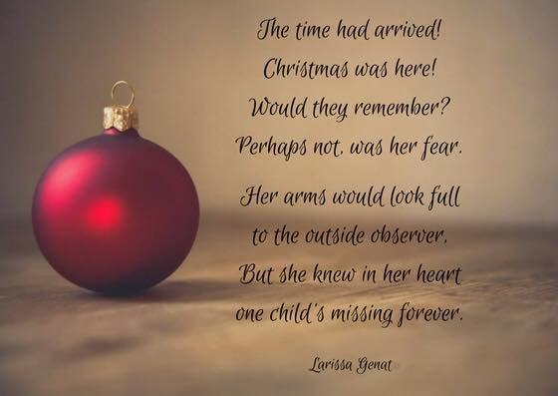

I’m Not Ready Yet
We should know better by now. It shouldn’t keep surprising us, but it does. No matter how hard we try, no matter what we do to prepare ourselves, it still happens. Year after year, generation after generation, it arrives without hesitation or delay. It stays too long and never lasts long enough. It is filled with anticipation and dread, and we never learn enough, and we know far too much.
It is greeted with great joy and heavy despair. And it is always announced by the universal cry of I’m not ready yet…” The HOLIDAYS are coming, and I haven’t even cleaned up the fireworks from the Fourth of July. I’m still unpacking boxes (we’ve moved…again!) and the calendar says it’s TIME for the annual migration of memories and the Great Stuff the Turkey contest (the turkey won last year). Because we’re in another new place, there will be the dilemma of where to put the tree and how do we explain to the company about that one empty stocking?
Nothing fits this year! The kitchen is too small for the turkey and the flamingoes are going to freeze in the 20 below temperature. I haven’t memorized my address and the grocery store is in the wrong place.
…I’m busy knitting little sweaters for the flamingos left over from life in the SWAMP, and practicing with the snow shovel. I keep forgetting where I’ve hidden gifts I bought last summer, and nothing seems to fit in the place like it did in the last one!
We were comfortable in the last place…but then I forget that is what we said when we first moved there too. We always seem to be more comfortable in the last placer…at least we know where the memories are and where to put them and how to handle them. Here in the new place, no one knows our “story.” No one knows our history…it is as if we have NO PAST. It’s easy to blend in, and not so easy to settle in…and The holidays are coming, and I’m not ready yet….
I’m not ready yet…the universal cry of all living beings. I’m not ready yet for first grade, for crossing the street by myself, for sleep away camp, for junior high, for getting married, for getting a job, for having children, for burying someone I love. I’m not ready yet…for grieving, for handling the holidays, for stuffing a turkey, for finding a place for everything, for living where no one knows my story. I’m not ready yet… for Halloween, for Thanksgiving, for Hanukkah …or for blizzards or frozen pink flamingos.
I’m not ready for the annual flood of memories that always spill out as we unpack the stockings from their tissue wrapped nest. I’m not ready yet…for the clutch of pain that still wraps my heart in grief as we place the ornaments on the tree. I’m not ready yet…for opening the door to greet strangers who are fast becoming friends but who may never know the effort it has taken to be who I am now.
I’m not ready yet to be “normal” and take my place among the normal people of the world. We look normal. For the most part we act normal. (We do, however, have sweater clad pink flamingos in the yard, holding our SEASON’S GREETINGS sign…) We are normal…except for OUR STORY and for the tears in our family fabric. But no one knows those tears anymore and I don’t think I’m ready not to have a past just yet. I don’t think I’m ready for no one to remember our hurt, let alone the joy our loved ones gave to us.
I unpack the silver today, intending to polish it and place it in the dining room so it would add its shimmer to the festive decorations. I wasn’t ready for the flood of memories that came back when I traced my fingers over the delicately carved designs in the coffee pot, remembering my mother patiently teaching me how to polish good silver. I wasn’t ready for the loneliness that swept over me as I placed the tea pot on the tray and suddenly wanted to call MOM and tell her I was, at last and again, home. She had taught me that silver always spoke of a comforting home…and now that I had found it and set it out, I wanted someone to remember with me all those talks my mom and I had shared.
I’m not ready yet…to live only on the surface of life. I want to share my history with my new friends, yet it seems unfair to me to spoil their holiday season. It’s not the same for me; there is still a lot of empty in my heart. Not as much as before, but now the emptiness comes from being too new anywhere to really belong.
So…I’ll just have to figure out how to handle the holidays I’m never going to be ready for in places I may never be settled in. As long as …the silver is polished and ready, then let the holidays come! We’ll figure out how to tell enough of our history, so we won’t be lonely and so people will understand about the flamingos and the tiny empty chair and the joy that lights up our life when we grasp hands together in the family circle.
We’ll decorate our new house (your new life?) with the treasures that speak of our history, finding joy in the memories they spark. We’ll bring with us some of the old, add a few pieces of new and practice the art of blending yesterday with today in hopes of creating another memory for tomorrow. I guess it doesn’t matter if you have moved or have never left the same place for generations, it is still an unsettled feeling the first time no one remembers the journey you’ve been on. The first time no one mentions your child’s name starts a hollowness in our being that leaves us empty and feeling alone. It is as if the world has made its move again and everything that once was so awkward and out of place has now assumed a “normal” atmosphere and most of the world “forgets” the price we paid for this “near normal.”
I’ll hand the special ornaments, enjoy the silver tea pot and cherish the warmth of the love these gifts of remembrance bring. No one else has to know the story for me to acknowledge it and remember it. No one else has to know the pain for me to share the joy of having these things be a part of my NOW. We’ll gather together and count our blessings, not only naming the ones around the table, but including those whose lives have touched ours in countless ways. One does not have to be present to be alive in the hearts of those who shared a few moments of the journey together. The heart never forgets …even when the world does.
No, nothing fits this year, just like nothing fit last year or the year before. But it’s getting better, improving either with age or experience or patience. Or maybe it’s because it is simply becoming a thread in the continuing fabric of our lives. We will probably always be a bit unsettled, unnerved when the roll call finds a name missing or a chair empty. But, then why shouldn’t we be a little sad when a light goes out in our world?
So, this holiday season, gather in your blessings and count them ALL, knowing that no one else has to know about them for them to be real for you. Just because no one else knows THE STORY does not mean it is any less real. Count the blessings of the people in your story and find the peace that comes with counting a holiday of joy remembered & love shared.
Peace to us all…wherever we may be.
--by Darcie D. Sims

The Island of Misfit Parents
In the Christmas animation “Rudolph the Red Nosed Reindeer,” Rudolph and his friends go to an island full of “misfit toys.” The toys are stuck there because they are different. The choo-choo train has square wheels, and the jack-in-the-box doesn’t have a spring. These toys are broken and left alone with no hope. As a bereaved parent, those have been my feelings exactly. For many years I too could not see beyond my island.
Eventually Rudolph returns safely to the North Pole. He tells Santa about the island and the broken toys. Santa goes to the island with his elves, and the toys are repaired. They don’t look all shiny and bright like new toys, but they do have hope beyond the island now.
Had I written this article prior to this year, I’d have stopped at the fact that the toys were broken and saw no hope. For most bereaved parents, that is quite true for some length of time. Now my ending tells me (and you) that there is hope beyond our island. We won’t be shiny and brand new, for we all have gone through many changes. But after much time for repair, we can experience the feeling of “hope” once more.
--Holiday Blessings.
--By Linda M. Trimmer
We Can Make It
During the holiday season, both Christians and Jews light candles in celebration of their respective faiths. As they do so, even the darkest rooms become warm and bright from the glow of a candle. Then we can ask ourselves, how powerful or sinister can the darkness be if it can be overcome by the light of one little candle?
There is then a message in this for all of us. When the darkness seems to overwhelm us--and it can be a mental and spiritual darkness as well as the darkness of a winter night --we need to be reminded that it is powerless to withstand the smallest bit of illumination.
So as the world grows colder and darker during these winter months, we as bereaved parents must do what people of many faiths have been taught to do at this season. Light a candle in someone’s life to make the darkness and fears flee. A little bit of light is all that most of us need, but oh we need that little bit so badly.
--Bettye & Sam Rosenberg, Louisville, KY
The New Year
After the holidays, we will be off on another 365. Some of you, I know, wonder if you can make it. That’s such an enormous amount of time to contemplate all at once, isn’t it? You may have some of your “firsts” coming in the months ahead, and the normal impulse seems to be to lump all those days together and dread them concurrently, like a prisoner serving several life sentences.
It’s possible to do it that way, but that’s the hard way. Getting through this day may take all the energy you can muster. Why try to handle March or May or July (or whenever your special days are) now? You can’t really, and by trying, you end up only defeating yourself in your effort to effectively survive this day. When this day is past, March or May or July will still be there, trying to defeat your tomorrow—but only if you let them!
Get past this day--and tomorrow and tomorrow and tomorrow. By the time March, May or July gets here you’ll have improved your coping skills. You can better handle your special days with more practice. I encourage you to know you can and will be better. Use this New Year to work toward that end.
—Mary Cleckley, Atlanta, GA

“Merry” Christmas
I question if Christmas can ever be “merry” except to the heart of an innocent child—
for when time has taught us the meaning of sorrow and sobered the spirits that once were so wild,
when all the green graves that lie scattered behind us
like milestones are marking the length of the way,
and echoes of voices that no more shall greet us have saddened the chimes of a bright Christmas Day—
we may not be merry; the long years forbid it—
the years that have brought us such manifold smarts.
But we may be happy if only we carry
the spirit of Christmas deep down in our hearts.
Hence, I shall not wish you the old “Merry Christmas,”
since that is of shadowless childhood a part,
but one that is holy and happy and peaceful,
the Spirit of Christmas deep down in your heart.
Chanukah Is Here
Chanukah is here.
I see the candles glow, red, pink & blue.
But you’re not here to see their pretty shadows.
I shop for gifts. And this year, again,
once more, I won’t be
in a quandary of what to buy.
I give you my love, my precious son,
for that is eternal.
And once again, it will have to do.
--Ginette Kravet, Central Jersey TCF

You know you don’t have with you anymore the child you are longing for. It probably seems sometimes that you hardly had her at all. Time passes so quickly. But what does that tell you, if you can listen and hear it? That life is temporary. You may have him only in memory, but you do have others who are here right now, who mean so much to you. Celebrate the temporariness of life with them.
You thought life with your lost love would go on and on. You didn’t expect to lose your child. Let this difficult lesson be learned, and enjoy the life you have with those who are here right now. Love them while you have them and they have you. And for goodness sake! Let them know you love them. What a gift you’ll give them!
--Donna Kruger

For those who think that Christmas and Chanukah are just nice days to give and get presents, bereaved parents have another message. Mixed with the joy is the knowledge of sadness. With the hope of birth comes the threat of death. We should not try to cover up our sadness in front of people, for we have a lesson to teach them.
But the holidays have a lesson for us too. Yes, there is death. Yes, there is great bitterness in life. There is darkness. But there is hope. There is birth. There is light.
In a society which works too hard to deny death, perhaps only bereaved parents & a few others can truly understand the depths of these holidays
--Dennis Klass, TCF, St. Louis, MO

All around you, light and laughter
All around you, carols toll.
Christmas, yes—but so soon after
such a loss to heart and soul?
In the distance, bells are ringing,
houses glow with festive lights.
How can voices still be singing?
This should be a silent night.
Someday, Christmases may find you
laughing as in days long past—
Memories may yet remind you,
love alone is made to last.
So, for now, may these words shine
through night & day to where you are,
Love transcends the darkest times…
It’s the light of every star.
--Jim Howard


Traditions
Have you been taught
to cry without a sound
(the tears descending
like a cutting edge)?

Have you been taught
to smile beyond endurance
(your throat an aching
lock around your heart)?
Have you been taught
to owe the world your service
until your mind
seems not to be your own?
Do not consent.
Truth teaches other lessons:
grief needs to sob aloud;
grief does not want to smile;
grief wants to serve
your inner healing, first.
In Time…
When we grieve and hurt, we seem to
be more aware of everyone’s
shortcomings, mistakes and limitations.
When we grieve and hurt, we seem to be
less capable of forgiveness and understanding.
When we grieve and hurt, we must try
to realize that feelings of anger
and bitter frustration are natural.
We must also recognize that most of
this angry sensitivity is temporary.
In time, we will rediscover our ability to understand and forgive
many people,
not only others in the world around us, but also ourselves.
The important word here is “IN TIME”
Solace
In the smallest hour of your day,
when you are alone
with things remembered,
questions unanswered
and unfinished dreams, then:
give to yourself
the gifts of your kindness,
bring to yourself
the comforts of forgiving,
share with yourself
the mercy of your love.
Who Is to Say—
Love and death
are the most powerful events
in human experience.
Joy and grief
are the natural companions
of love and death
Who is to say
that we could have
love and joy
if we had not
death and grief?

Giving Thanks
I cannot hold your hands today,
I cannot see your smile.
I cannot hear your voices now,
my children, who are gone.
But I recall your faces still,
the songs, the talks, the sighs.
And story times and winter walks,
and sharing secret things.
I know you helped my mind to live
beyond your time with me.
You gave me clearer eyes to see,
you gave me finer ears to hear,
what living means,
what dying means,
my children, who are gone.
So here it is Thanksgiving Day,
and you are not with me.
And while I weep a mother’s tears,
I thank you for the gifts you were,
and all the gifts you gave to me,
my children, who are gone.
It’s all right to…
Scream in the shower.…
Yell in the car.…
Cry anywhere you like.
Misplace your glasses, the car keys and the car.
Put milk in the cupboard, toilet paper in the refrigerator,
and ice cream in the oven.
Beat up on the pillow,
stomp on the ground,
Throw stones in the lake,
Change grocery stores if it hurts.
Wear one black shoe and one navy.
Have tear stains on your ties.
Eat french fries for breakfast,
toast for lunch and peanut butter for dinner (as long as you eat).
Write him a letter.…Bake her a cake.
Smell his clothes.…
Celebrate his life on his birthday.
Talk to your pets, they understand.
Leave his room the way it is,
for as long as you like.
Say her name just to hear the sound.
Talk about him to others.
Tell loved ones what you need.
Say no when you feel like it.
Cancel plans if you want.
Have a bad day.…It’s all right to hurt.
And one day when you’re ready
it’s all right to…
Laugh again.…Dance and feel pretty.
Have a good time.…
Look forward to tomorrow.
Sing in the shower.…
Smile at a friend’s new baby.
Wear make-up once more.
Go for a day, a week, and
even a month without crying.
Celebrate the holidays.
Forgive those who failed you.
Learn something new.
Look at his picture and remember
with happiness, not pain.
Go on with your life.
Cherish the memories.
And one day when it’s time…
It’s all right to love again.
--Vicki Tushingham,, TCF, Bergen/Passaic, NJ

Another Year
Another year is starting. A new slate, fresh, nothing written on it, no joys, no sorrows. It's an opportunity, and an obligation.
What will it be like? What will it bring? There will be many events over which we can have no control. And there will be things over which we cannot exert our influence.
What do we want from this yew year?
First, we need to realize that there is no magic. Solvable problems are the realistic ones to tackle. Take some time to dis-cuss and identify a few things you can do to make this new year at least decent (remember, you're allowed to be happy).
There is a song that includes in its lyrics, "All the people tell me so. What do the people know?" If they haven't walked in your shoes, most of them don't know much about what you're having to do. So, don't measure yourself with their yardstick. They think you should have done this, not done that, have completed the other. You're the one who's doing it, so you figure out what's realistic and possible for you. And try it. Don't be afraid to revise your plan, revamp your schedule. It's not written in stone.
Be good to yourself. Small pleasures can bring small joys. Small joys are better than none. The odd occasional treat—flowers, a special food, dinner out, a trip, calling a friend, a walk on a nice day—you know what pleases you. Don't be afraid to be kind to you.
Help someone else. It may not sound logical, but to reach out to another hurting heart in friendship, love and caring, helps to heal our own wounds. A hug, a note, a phone call, sharing something you've written, doing things for your TCF chapter that will help others—they help you too.
Another year is starting. With work and determination,
TOGETHER WE CAN MAKE IT!
--Joan D. Schmidt, TCF, Central Jersey
Dear God, please let this be…
- More than a page from the calendar
- A year of healing and health
- A year of forgiving past hurts
- A year to reach out to someone else in my child's memory
- The beginning of a new positive outlook
- A year of wondrous new accomplishments
- A year to really show the people in my life how much they mean to me
- The year I finally stop asking why and accept what is
- The year when I start taking better care of myself
- A time to stop dwelling on the shortness of my child's life and just be grateful that I had her at all
- A year to thank You for all that You've given me, even the things that didn't seem like such a blessing at the time
--Kathy McCormick, TCF, Lower Bucks
Winter Questions
the year has gone again
from spring to winter—
and in this year,
your memories may have found
a breath of calm between them,
quiet respite—sometimes…
then why must there be
twice as many now—
these feelings, now,
these visions, songs and voices,
from Halloween to New Year's:
twice memories and smiles,
twice memories and tears…?
you know the answer,
even while you cry:
the tears are,
(like the smiles)
a season's song of love.
--Sascha Wagner

As the year is drifting away
We remember the grievers
The friends and the strangers
Whose children have gone from this life
In the year that is leaving us now
We remember the grievers
The friends and the strangers
We wish them hope.
--Sascha Wagner
To Start a New Year
If I can concentrate
On the moral and spiritual
Side of the holidays
I can make it through.
If I can absorb
The love and warmth
That was the beginning
I can give love back.
If I can share
The grief and the love
That is in me
Through these holidays
I can start a new year.
—Tom Spray, TCF, Ventura County, CA

TCF asks for donations in memory of our children who have died. Our activities support the grief work of many families. We also work to educate members of our community about the grief process & how they can support bereaved parents.
Please help us help others. Make a LOVE GIFT today. Tax deductible Love Gifts may be sent to: TCF C/O Carol Cavin 214 E Hansen Ct, Independence, MO 64055
For Remembrance dates please visit our website at www.easternjacksoncountytcf.org
Find us on Facebook at https://www.facebook.com/groups/1582699755290182
We have several volunteers who write remembrance cards to families on birthdays and death dates. Just a reminder if you have an address change please email phillipsplace@aol.com or mail a note to TCF, C/O Theresa Phillips 6200 Kentucky Raytown, MO 64133 so the roster can be updated.
Please remember that you can give to The Compassionate Friends through your United Way pledge at work or as a single gift, but you MUST WRITE IT IN

