May-June 2020
Chapter Leader: Theresa Phillips TCF National Headquarters

24-Hour Help Line: (816)229-2640 PO Box 3696, Oak Brook, IL 60522
Private Facebook Page: Eastern Jackson County TCF Website: www.compassionatefriends.org
Website: www.easternjacksoncounty tcf.org 630-990-0010

Can We Skip This Day?
Tips on Handling Mother’s Day, Memorial Day, Father’s Day
Survival isn’t instinctive anymore. Sometimes, after the death of our child, apathy takes over. Coupled with celebration of motherhood or fatherhood in the absence of our child it can be a slap in the face. Here are some helpful ideas for parents enduring their first, or yet another Mother’s Day and Father’s Day. (The Editor is very sorry that you are reading this too late to help with this year’s Mother’s Day. Set it aside to read again next year.)
T.E.A.R.S.
T – Take care of yourself! Go the extra mile to make your-self as happy as possible. ♥ Surround yourself with people who make you feel comfortable in your grief. ♥ Exercise is also a great outlet for grief. Sometimes, a hike alone or with your partner is a nice way to spend the day. ♥ Take a bubble bath with your favorite music playing in the background. ♥ If you have other children, dedicate half the day to a Mother’s or Father’s Day celebration with them and the other half alone or with your partner. ♥ Some parents will find a visit to the cemetery therapeutic. ♥ Cry, cry, cry—tears have a healing effect, and you have definitely earned these tears.
E – Embrace the memories [if you can] by looking at photo-graphs, watching video tapes, sharing poetry or making a special cassette tape of songs which remind you of your child. At first it may seem overwhelming [if it’s too much, keep it in mind for next year]; however, many couples say that those times of sharing bring healing to the family. It is a gentle reminder to the entire family that this child will always be your child.
A – Acknowledge feelings of grief and doubt. You may wonder if you should “celebrate” without your child. It may seem pointless. Give yourself permission to have these feelings and accept them. Prepare for the likelihood that the “day” will be difficult; however, many parents say the days before the actual holiday are much worse than the day itself. If you do have feelings of joy, try not to feel guilty. The grieving process allows room to breathe in between the waves of grief.
R – Routines can be changed! If you typically spend Father’s Day with a large family group, but this year it seems awkward or too painful without your child, excuse yourself from the routine and establish new traditions which are more accommodating to your grief. Sometimes, more intimate and personal gatherings make grieving parents feel more comfortable in sharing their honest feelings about the special event and the death of their child. Consider a gathering with other bereaved parents you may have met through a support group.
S – Seek out ways to memorialize your child. Some ideas: ♥ Light a candle at a specific time every year on this special day. ♥ Light luminaries in your yard. ♥ Create a collage or special album of photographs of your child. ♥ Plant a tree or flowers in your child’s memory. ♥ Buy something that reminds you of your child. Having a specific theme is helpful, like angels, butterflies, Disney characters, or other themes. ♥ Reaching out to others on a special day [such as visiting shut-ins or a nursing home, donating time at an animal shelter, or making a donation to TCF, a community pantry, a shelter for battered women and children] honors the memory of your child.
Another suggestion for partners, family members and friends is to make a phone call, or send a note or greeting card on the special day acknowledging the child. This is very important to parents, and it reassures them you have not forgotten—they certainly have not.
--By Joanne Cacciatore, TCF, Phoenix, AZ, Director of AZ SIDS Alliance; founder of Mothers in Sympathy and Support; RTS counselor; © 1998.
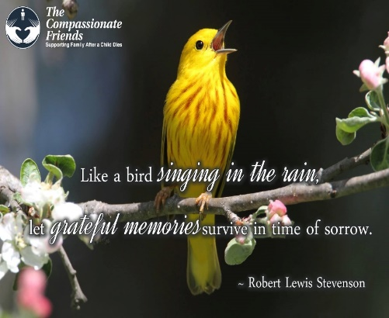

To My Husband
Your tears flow within your heart.
Mine flow down my cheeks.
Your anger lies with thoughts and movements.
Mine gallops forth for all to see.
Your despair shows in your now dull eyes.
Mine shows in line after written line.
You grieve over the death of your son,
I grieve over the death of my baby.
But we’re still the same, still one.
Only we grieve at different times,
Over different memories and at different lengths.
Yet we both realize the death of our child.
--Pam Burden, TCF Augusta, GA
To the mother who has lost her only child, or has no surviving children, the thought of Mother’s Day sends a stabbing pain that only the ones of us who are in this situation can understand. We begin to notice Mother’s Day cards slipped in right after Valentine’s Day along with the Easter cards. Even before Easter the TV advertising starts. We try to blot this all out but our subconscious keeps reminding us, the day is coming closer.
For the first two years we celebrated Mother’s Day for my mother and sister very quietly. The third year after my daughter Shawna’s death, we decided to go to a local restaurant featuring a nice buffet. We arrived early hoping to avoid the crowd. A very flustered hostess greeted us and found a table for us. The tables had been pushed close together to accommodate more people. It was already becoming very crowded. She asked the question, “How many mothers?” It was then we noticed the flowers she was carrying. Someone managed to stammer out, three- three- mothers. She handed us each a flower, while glancing around to find a table for the next group of people. She didn’t notice the one she handed me was pretty battered.
My sister wanted to give me hers or get another. “No, it’s okay,” I said. The stem was bent, but not broken completely. A wilted, tired flower was hanging from the stem. I brought it home and propped it up in a glass of water to revive it. You see, I could identify with that flower.
As a mother without my child, I have felt so bruised and battered. Somehow through all the pain, tears and loneliness, like the flower, I have been bent but never quite broken.
--Donna Frechec, TCF Enid, OK
Missing and Valuing
on Mother’s Day
Mother’s day is a special day, and special days are hard after the death of a child. It is a normal and natural thing for either parent for the first few years after the death to zero in on who is missing rather than who is left…and I was no different.
Fortunately for me, not long after the Atlanta TCF chapter formed, a local psychiatrist, Dr. Victor Gonzales, spoke one evening shortly before Mother’s Day. He told of his parents’ loss of their first two children. His story, of how his life had been influenced and molded by his mother’s reaction, touched me. He spoke of how he and his siblings who came later were forever denied his mother’s happiness and joy. She was unable to value what she had left as much as what she had lost.
Dr. Gonzales said he spent a great deal of his childhood trying to make his mother happy, always failing and always feeling there must be something lacking in him that caused him to fail. The picture in my mind of him and his siblings always trying and always failing through no fault of their own, made a great impact on me. I determined from that day forward that my daughter would not have to lament later in life that she had been denied my happiness and joy be-cause her brother died.
On Mother’s Day now I make room for both missing and valuing, for they are not, I have discovered, mutually exclusive. Now when I go to the cemetery with my rosebud on my day, my daughter has no part in my needs while I am there. When I come home, my son doesn’t interfere with my acceptance and appreciation of my daughter’s expression of love. She gives me a gift on my day, & I give her one in return. It’s probably the best gift I could possible give her—my happiness and joy for life. She is as important as what I have lost, and I know her worth.
If you are fortunate enough to have surviving children, I hope you too are able to value as well as miss. There’s room for both, you know.
--Mary Cleckley, Bereaved Parents of the USA

Something to Think About
Life made us a bargain,
when we first came into this world:
That as surely as we live, someday we will die,
As surely as we laughed,
someday we will cry.
So that for all the assets that life and health and joy bring,
They are balanced on earth by hate and disease and sorrow.
Our sorrow is the price we pay for all the love and joy we took so freely.
We needn’t weep such bitter tears if our laughter had not been so sweet for years.
If the price I pay for loving Jared is the pain,
anguish and sorrow I now have,
Then I know I got a bargain
to have had him for 13 years!
If the only way to avoid the pain is to also
avoid the pleasure of loving someone,
Then love them with all your heart and soul, and mourn their loss the same,
And count your life a bargain
for having loved.
--Dale Travathan, TCF Tulsa

Then and Now

I remember yesterday
When my life was full of joy,
But that was then
My girls were there
Our moments, we enjoyed.

Always laugh and tickled
We’d squeal, squirm and giggle so.
Sarah laughing
Just so silly
Her chin up tight and yelling “no.”

Amy sang her funny song
Be I Be, B I Bo,
Our car would laugh
As we all sang.
On we went and on we’d go.

Their mother tried so hard
To chime in and make us proud.
Eye in the sky
Look’n for something.
Silence...then we’d laughed out loud

Now is now and always will
Day after day, year after year
My heart so full
For both my girls.
Our love together and always dear.

That was then and now is now
My memories full, my heart in sync
That makes me grin
That makes me smile
Two precious girls, I often think.
~Don Batson, TCF South Kansas City
Father’s Day 2018

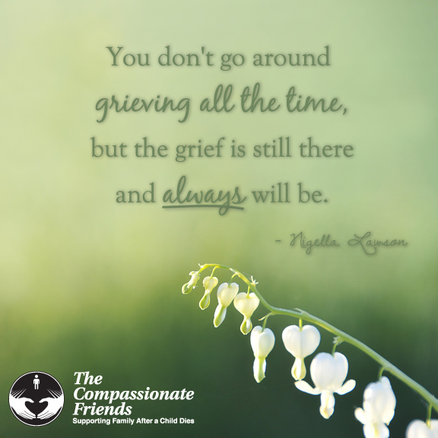 Someday…
Someday it won’t hurt so bad and I’ll be able to smile again,
Someday the tears won’t flow quite as freely whenever I think of what might have been,
Someday the answers to “why” and “what if” won’t be quite as important,
Someday I’ll be able to use what your death has taught me to help others with their grief,
Someday I’ll be healed enough to celebrate your life as much as I now dwell on your death,
And someday, maybe tomorrow, I’ll learn to accept the things I cannot change…
But for today…I think I’ll just be sad.
--Steven L. Channing, TCF Winnipeg

Slow Dance
Have you ever watched kids on a merry-go-round?
Or listened to the rain slapping on the ground?
Ever follow a butterfly’s erratic flight
Or gazed at the sun into the fading night?
You’d better slow down, don’t dance so fast,
Time is short, the music won’t last.
Do you run through each day on the fly?
When you ask, “How are you?” do you hear the reply?
When the day is done, do you lie in bed,
With the next hundred chores running thru your head?
You’d better slow down, don’t dance so fast,
Time is short, the music won’t last.
Ever told your child, we’ll do it tomorrow,
And in your haste, not seen his sorrow?
Ever lost touch, let a good friendship die,
‘Cause you never had time to call and say hi?
You’d better slow down, don’t dance so fast,
Time is short, the music won’t last.
When you run so fast to get somewhere,
You miss half the fun of getting there.
When you worry and hurry through your day,
It is like an unopened gift…thrown away.
Life is not a race; do take it slower;
Hear the music, before the song is over.
--In loving memory of Angela C. Cook (10/2/67-5/15/00)
Mother—Lorraine Cook, Brother—Tom Cook, Jr., Nina Emily Cook

Adieu
I imagined this spring year
they graduated from college.
You were all such good friends
from early grammar school.
I pictured there must have been
wonderful parties with lots of potato salad,
gowns to press and caps to block.
I imagined their desire to get that
“extra ticket” for grandma
and one for a special friend.
I visualized driving past their homes,
hoping for a glimpse of movement
behind their open windows.
I tortured myself with guesstimates as
to what degrees they received.
I hoped that one would call and share
with me their happiness and pride.
I walked the narrow path today,
sat on the cold marble bench
near your grave
and finally
bid them . . . all
Adieu.
--Esther Rosensweig, TCF
Manhasset Chapter, NY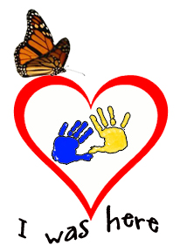

Graduation Day
It’s June and graduation time again. Your child would have been among those wearing the cap and gown, walking down the aisle to the ever stirring “Pomp and Circumstance.” Now there will be a vacant spot in the line. Should you at-tend? Can you stand the pain? Will people think you’re strange?
As always, you must follow your heart. So, go if you’d like to, and don’t hide your tears. It’s quite all right to miss your own child when celebrating the achievements of others.
Just remember that your own instincts are the most important ones, that no one else can make this decision for you; and it doesn’t really matter what other people think of you. It was your child who died. This is your pain, and you have the right to feel it and deal with it in your own way—and may a bit more healing take place in the doing.
--Peggy Gibson, TCF, Nashville, TN

Rituals
I don’t know why rituals help us heal, but often they do. One day, less than a year after Philip had died, a friend and I met on a private beach in Gloucester, Massachusetts. The beach was special to both of us, because the mother she had lost and the son I had lost had both spent wonderfully happy hours on it.
We didn’t quite know how to do a ritual, so we made one up. We each gathered a large handful of stones, and then we sat down on the sandy beach with our stones by our sides, facing one another. Each of us in turn placed a stone down on the sand, and as we did so, we shared something about the loved one we had lost. Our anecdotes ran the gamut from happy and funny to sad and longing. We laughed, we cried. Gradually the stones formed a circle, & we then placed the two remaining stones in its center, in honor of Philip and her mom. We stood up, hugged, and went to have lunch at a favorite place nearby. There we shared photographs and more memories. By the time we parted, we both knew her mom and my son were happily alive in both our memories. And we felt wonderful for having celebrated their lives together.
After I moved to California, I met my dear friend Nell at the first TCF Marin meeting I attended. And ever since, on the birthdays of our sons and on the day they each died, Nell and I have gathered at a special beach to do our own ritual, similar to the first but unique to us. We like to toss flowers into the ocean in honor of John and Philip. Nell often brings something to read, which I like and will do in the future too. We laugh and cry. We often, but not always, do the circle of stones. I love that I’m getting to know her John, and that she is becoming acquainted with my Philip. Though our two be-loved sons died, their spirits, their humor, their extraordinary creativity and their love are very present in these gentle sharing times.
I encourage you to do whatever rituals are helpful and easy for you. Feel free to borrow ours. May whatever you do to celebrate and remember your child touch and bring ease to your heart.
--Catharine (Kitty) Reeve, TCF Marin & San Francisco

Grief Chooses You
You somehow think I want to grieve? It’s not a choice I make.
It doesn’t serve as therapy like ripples on a lake.
It’s not as therapeutic as a non-believer thinks
and signals immaturity with alcoholic drinks.
No, I don’t choose to wallow in the grief that clouds my mind,
but focusing on memories has also not been kind.
It may seem like it helps one out and gets one through the sting,
but that’s like knives brought to a gunfight; jesters playing kings.
I wouldn’t wish on ANYONE the anguish I go through.
But understanding why I grieve? Admit you have no clue.
You haven’t walked the journey in these shoes I have to wear,
‘cause if you had, you wouldn’t be there standing with that stare.
You’d realize we do this to preserve our sanity
and steer clear of harsh words that border on profanity.
Opinionated families don’t take the time to know
the probabilities from pain when one has been loved so.
They somehow think they’ve got the right to tell one when to grieve,
but let them lose a loved one, too. They’ll surely then believe.
Insensitivities expressed are often best ignored.
Why focus on the negative toward one so adored?
It’s personal and each one has their right to muddle through.
While looking from the outside in may seem nonsense to you;
the bumpy road you’re thrown upon presents disturbing facts.
And then you’re face-to-face with ruination to the max.
But just like grief, most would agree love also has its way
to capture hearts and give one strength to live another day.
While we can overanalyze what love might choose to do,
even Albert Einstein would say grief chooses you.
--Cary Gregory, Kellie’s father and author of Kellie’s Book
The Father’s Grief
--By David Pellegrin, Honolulu, HI
At my second meeting of The Compassionate Friends three years ago, one of the mothers said how nice it was to see a man attending, since “men grieve differently from women.”
Her remark was no doubt meant to help put me at ease. I hadn’t said a thing so far, and might have been intimidating in my silence, but it caught me off guard. What I was feeling after George’s death, was so absolute, so awful, how could it possibly come with any “differences”? Would one grieve differently for an infant than for an adolescent? For a son than for a daughter? Surely grief was absolute for both mothers and fathers.
Over time I came to acknowledge the differences the well-meaning mother had in mind:
- Neither I nor the other men who occasionally attended talked much; the women talked freely.
- I sensed I was better at compartmentalizing my grief than the mothers, better at keeping a lid on it socially and at work.
- My male friends seemed less comfortable than female friends in talking about George, bringing up his name, or even looking at his pictures.
- I came to see how intensely I felt that I had let my son down as his protector, the father’s primary role.
Shortly after becoming editor of my chapter newsletter, I sent a copy to my friend Jack Knebel in California. Jack and his wife, Linda, had been involved with a TCF chapter after the death of their daughter, Hollis. He replied, “It’s good to see that a man is taking an active role in the group.” Then he went on to write movingly about those male-female grieving differences. The rest of his letter, which touched me deeply, follows:
“…Several years after Hollis died, Linda and I were being trained by TCF to be “buddies” for newly bereaved parents. One of the exercises was to list all the unhelpful things that others had said in trying to comfort us, so that we wouldn’t make the same mistakes. The other trainees (who were all women) made long lists, and did it with enthusiasm. When the lists were read aloud, they nodded knowingly at every entry and eventually hooted and howled with derision at the worst (some of which were pretty bad). When it came my turn, I held up an empty page and said,
“People may have said such things to me. I just don’t recall. What I do re-member is that people tried to tell me how sad they were for us, how much they loved Hollis and how much they cared about us. I remember one of my law partners hugging me in the halls of our very stiff and proper law firm. I remember men who had never told me anything more personal than their reactions to a Giants’ loss crying at our loss and their fears.
“You women are used to talking about your emotions and about personal things. I wasn’t and my friends weren’t either. So the fact that we could do so was a great gift, and it wasn’t marred in the slightest by someone’s choice of words.
“Now, the shell has been broken and I find it easier to talk about my emotions, my hopes and fears, about those things that really are important. And that for me was one of Hollis’ greatest gifts.
“I know that even after George’s death, he is a major part of your life. My guess is that you’re becoming more open to the gifts that he and those who care about you are able to give. With compassion and friendship, Jack”
Gratitude...The Key to Happiness
I am convinced that the real key to happiness is gratitude.... I have thought a lot about this idea since my son, Mark, died five years ago. At first I was of-fended by people who smiled or even laughed during a TCF meeting. These were people who seemed to have some-how re-entered the land of the living. ...How dare they laugh? How dare they appear normal when their children have died? But over the last five years I have learned three valuable lessons:
- Life goes on and we must too. Gradually the pain eases and the warm memories replace the sadness. Gradually we return to life. One day we find that it is 11:00 am and we have not thought about our child yet. At first we feel guilt, but then we also realize we are going forward. We will never forget, but we decide that the loss of our child will not be the all-consuming factor in our life.... I am convinced that this is what our children would want for us.
- We become grateful for what we have, not focused on what we have lost. I see people in our chapter’s meetings every month who have gone through “every parent’s nightmare” and want no part of life again. But I ask that [they] also think about the ways they have been blessed, as well as hurt. In my experience, most people have more to be thankful for than they realize: health, other children, a loving family...life in a free country, faith that works for them, a true best friend, a spouse whom they love. Nobody has it all, but compared to most, ...we have a lot.
- The life we now lead will be better than it would have been. That does not make our child’s death a good thing. It just means that our child’s life mattered, and it has changed us forever. It means that in some small way the world will be better because our child lived, and we are the ones who can make it so. We have a new sense of priorities. We don’t “sweat the small stuff.” We know what matters because we know what is irreplaceable. And we know how deeply other people hurt, because we, too, have been there. We “know how they feel.”
And when our life is different and better because our child lived, then that child is never forgotten. Each of us would do any-thing in the world to go back in time, but we can’t. It is up to us now to go forward, and we can.
--Rich Edler, TCF, South Bay/LA, CA

A Father’s Thoughts on Father’s Day
Am I still a daddy
after my daughter is gone?
I have no one now
to toss gently in the air and hug
upon returning to my arms.
I have no one now
to blow “xerbits” on her belly,
generating billows of laughter.
I have no hand to hold
while she tearfully gets a shot,
no foot to tickle, no hair to comb,
no tears to comfort and
no child to hold upon my lap.
My heart would ache much less
if I weren’t a father.
So I guess I’m still a daddy
even though this daddy’s girl is gone.
--Larry C. Brincefield
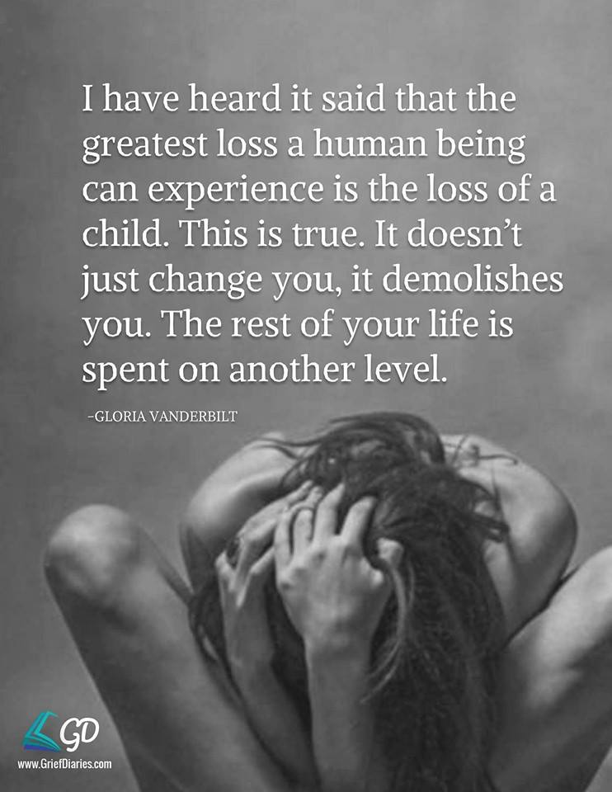
Summertime
It sounds so easy. A soft, warm word: time to run barefoot, time to leave windows open all night. Summertime. Somehow it seems, doesn’t it, that it’s especially meant for children? Children on beaches, children on swings, children in large pools, children in tiny tubs.
We who do not have all of our children with us may feel the summertime in two ways. One is to re-member shared events and adventures. There were so many: long rides in a hot car, a nap in the back seat. The famous question, “Are we there yet?” Everything from a heat rash to ice cream cones and sand castles.
For us, another way to feel summertime is an emptiness brought about by children who are no longer on this earth. They used to trot along on hikes in the hills; they used to gather wood for an evening fire. Now summer brings us again the melancholy awareness of their absence. Have you ever walked on some unfamiliar path, surprised about not having been there with the children? Even when there’s nothing to remember, we are reminded of their absence.
We have been diminished by death. Some of us may still have living children. Other parents have no children left. They have lost an only child, perhaps, or all of their children died. And here we are, grateful for the warmth of summer mornings, aware of the ripe beauty of nature, trying to deal with our children’s absence with all the grace of which we are capable. Often, we do not want to burden others with our grief. Or we may think that others don’t wish to share our distress. We have learned, after all, that the world around us is not always able to understand how we feel.
Besides, we were taught to be brave. Many of us will do everything we can to appear “normal” after our loss. But we were also taught to be honest. And when you feel the hurt, when you seem almost to be lost in the shadows of this golden summer-time, don’t hide your sorrow. The grief of your spirit can perhaps be kept a secret on the outside. Yet your deepest feelings, unexpressed, can burn into your existence with harmful force.
You can be both brave and honest. You know that it’s brave to share grief, be it old grief or new grief. And revealing that sorrow is also honest. Nothing, of course, can wipe away much of your pain, but sharing grief is helpful. You will understand after you have expressed the painful sorrow you once kept hid-den, and you finally find yourself smiling at the memories and the blessings of past summer times.
--Sascha Wagner

I’ve seen reports on the news about parents whose children were murdered, and these parents sought out the murderers to get to know them & try to help them, which is astounding until you think it through. In essence, what else could they do? Sure, they could take revenge, destroy the world. But that’s the worst hurt a person could have: to see his or her child senselessly murdered. So there are people who find a way to turn even that horrible, destructive energy into something positive.
It comes down to changing the way you look at a particular injustice. The parents whose child has been murdered seek to understand the murderer, and to try to salvage whatever is salvageable in human terms—in this particular case, a kernel of goodness in the murderer. Well, the parents don’t arrive there three days after the child has been murdered, nor do they arrive there some weeks after they’ve buried their child. They go through what’s probably an unbearable hell, because striving for control within them are the various human forces that command us: hatred, anger, fear, a sense of revenge. All of those forces have to play out individually and in groups and sometimes in juxtaposition one to the other.
And when those parents are unable to find easy answers, they have to face their pain. It’s when they do that—somewhere in that confrontation—that they may find some suggestion, some indication, some hint, some intuition that will lead them toward looking at the circumstances differently. And one day, one minute, one second somewhere along the line, they’re going to realize that there’s no way for them to live with the requirements of their anger…their rage …their hatred. They have to find peace, because they won’t get any peace from re-running those emotions. Somewhere along the line, I guess, out of nature’s inexplicable ways, they stumble on a light (or they consciously arrive at that light, or it comes from someplace unknown), and the seed of forgiveness is illuminated.
--Sidney Poitier, in The Measure of a Man
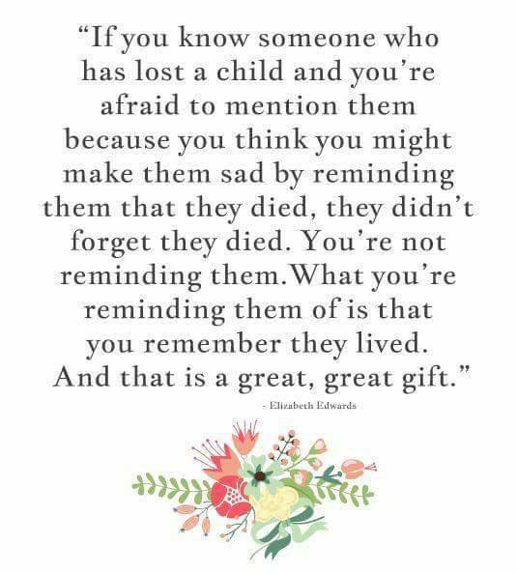

Mark your calendars for our Annual Walk to Remember on September 26, 2020 at Waterfall Park in Independence, MO.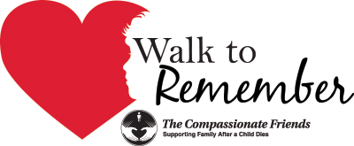

Remember when you came to your first meeting and someone was there who was a little farther down the road and gave you a hug or shared something that made you feel like you are not crazy. Well if you are a little bit farther down the road please feel free to come back to our meetings and help families that are just starting their grief journey.

Love Gifts
Please help us help others. Make a LOVE GIFT today. Tax deductible Love Gifts may be sent to: TCF C/O Theresa Phillips 6200 Kentucky Ave, Raytown, MO 64133
For Remembrance dates please visit our website at www.easternjacksoncountytcf.org
Find us on Facebook at https://www.facebook.com/groups/1582699755290182
We have several volunteers who write remembrance cards to families on birthdays and death dates. Just a reminder if you have an address change please email phillipsplace@aol.com or mail a note to TCF, C/O Theresa Phillips 6200 Kentucky Raytown, MO 64133 so the roster can be updated.
Please remember that you can give to The Compassionate Friends through your United Way pledge at work or as a single gift, but you MUST WRITE IT IN.

