 **May - June 2019**

**Chapter Leader: Theresa Phillips TCF National Headquarters**

# 24-Hour Help Line: (816)229-2640 PO Box 3696, Oak Brook, IL 60522

**Private Facebook Page: Eastern Jackson County TCF Website: www.compassionatefriends.org**

**Website: www.easternjacksoncounty tcf.org 630-990-0010**

**Reflections: An Afternoon at the Vietnam Memorial**

We stood silently watching a hushed and respectful line of visitors move slowly along the polished black wall. Dim sunlight of late afternoon caught the reflections of the black granite surface; engraved names of the dead and missing stood out in bold dark relief in the play of light and shadow.

A girl, no longer young, reaches up and runs her finger gently across a name, kneels briefly, and leaves a single rose at the foot of the monument. With bowed head she moves along then, quietly immersed in her grief. A distinguished older man, iron gray hair, somber face, asks a Park Service attendant’s assistance in making a rubbing of his son’s name.

We walk the length of “The Wall.” Names of friends and the sons of friends were not hard to find,…those…who died on black rainy nights when weather and mountains were of more danger than enemy fire--an able squadron commander who died leading a useless strike on Hanoi, ordered over our objection by some “theoretical genius” in Washington. Several names of the sons of friends who were dedicated to following the profession of their fathers; one who was the “kid next door” in Quantico years ago.

The pervasive quiet of the memorial, area seemed to me to be more a respectful silence than the sadness of grief. Time has served to soften much of the pain of the grief; I saw no overt expression of pain except for tears in the eyes—yet one could feel the grief of those present and of the many thousands of parents, wives, sweethearts, children of all the 58,249 young and not-so-young men and women honored there whose lives were lessened by death. I will take the quiet walk of deep respect and clear memory again.

I found the company there especially good; I felt again their obstinate insistence upon doing their duty as they saw it, in spite of the failures of national leadership, lack of clarity of purpose, divisive influences. Their gift to us was indeed that “last full measure of devotion,” a magnificent gift given under adverse circumstances, with marginal recognition of any sacrifice, much less the ultimate sacrifice.

So many friends of my youth I find now only in memory. Some died in training accidents; some lost in the trackless expanse of the lonesome spaces of Oceania, some in the jungles of the Pacific islands, some in the mountains of Korea, some in the mud flats and freezing waters of the Yellow Sea. Many are remembered now only by scarred old veterans, bereaved families and a few friends; others who came back have since fallen to the accumulation of physical ravages they brought home as “survivors.”

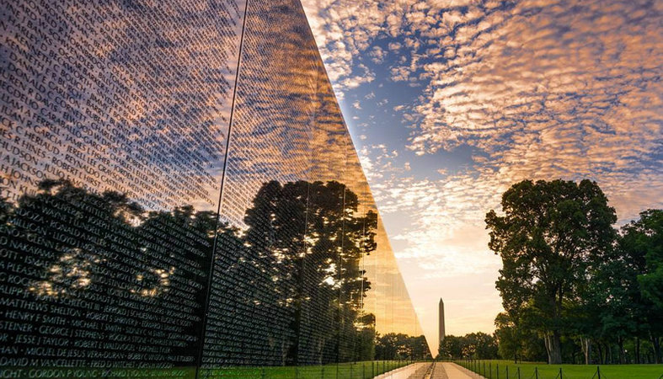

We honor them; they knowingly did what others could or would not do. For everyone who received acclaim, there are a thousand who fought in the muck, lived in the mud, suffered malaria and stranger diseases, multiple hardships of frozen terrains, spent dark nights guarding strange hills, in endless swamps, through weeks of rain or snow. One of my best friends was killed when we were 18, another, after 41 years of service-caused disability, died last week.

“Our nation honors the courage, sacrifice and devotion to duty and country of its Vietnam veterans.…The names would become the Memorial.…The personal legacy lives on…a service of individual human sacrifices…each name a special place in history…”(excerpts from the National Park Service Guide).

If we look back at their selfless sacrifice with great respect and great regret, we can also resolve with a firm conviction never to let the pontifications, ambitions and ignorance’s of a few blunder, for us, into a senseless sacrifice of our youngest and best. As Santayana wrote, “Those who refuse to learn from the lessons of history are destined to repeat them.” And each time we visit Washington, D. C., we take that walk again along the Memorial Wall, read the names and pay our respect to those who gave their lives for our country

**The Graduation Party**

You’ve been gone so long. I couldn’t feel the spirit of you over my sadness. My grief was taking me further away from you. Then you came to me. Just as I remembered you. Laughing, shining eyes. Moving so gracefully. So Alive. It made me happy just to look at you, for I hadn’t seen you that clearly in years.

It would soon be your brother’s graduation, and I wondered how I would get through it without crying for you. “YOU should be here...YOU should be part of this,” I cried.

“HAVE A PARTY!” You bounced the words at me. “No,” I said. “You were our party person.” We could hardly have company over, especially without you egging us on. But as the days went by, those words continued to gnaw at me, or was it you?

Last night your brother graduated. We had a BIG party...lots of friends, lots of laughter, lots of memories and YOU. The banner, the balloons, all were touches from you. For a while you were back with us. It felt so good.

*--Lynn Kulp, TCF, Sonoma County, CA*

**The Police Officer**

My son Spenser had been dead for about a month. Only ten, he had died from blastocytic lymphoma. I sat at my desk in the office, reading a case file at about ten to twelve.

I can’t tell you why, but I suddenly had an urge to get out of that building. I didn’t even know where I was going. I just put on my walking shoes and started to go. With a push on the bar of the glass door, I thrust myself into the wind corridor that whistled around the building. Walking in the shadow of the monolithic edifice, I spied a flower bed, glowing in neon brightness, far away on the northeast corner of the government building grounds. The flaming scarlets and magentas blazed as though on fire.

Grey, faceless people passed by me as I strode toward the flowers, never taking my eyes off the ethereal swirl of the hypnotizing colors. They beckoned to me from a distance, luring me to their intoxicating flower bed. I wondered whether these were common bedding flowers of a different color, or a new species previously unknown in Kansas. I had to know.

I crossed the street to the northeast corner and stopped with a jolt. The names of slain Kansas police officers glistened in dull gold on a plaque mounted on a massive jagged rock. The seductive flowers enticed me to this spot and knowing that I might be confronted with the name of James Hart, I wanted to flee. Spenser loved action figures, and although he never knew James Hart, he would have loved the tall, dark police officer who died in the line of duty. That is why we buried Spenser next to the grave of James Hart.

I stood before the memorial rock, trembling. The name of James Hart would be carved somewhere in the concrete and stone memorial, but with so many inscribed names, I hoped I would not be able to find it. Yet there was his name, James Hart, front and center. My breaths grew shallow as I hovered like a bird, the second before it flies away.

This was no coincidence, and there was no exit. I collapsed onto the stone bench, surrounded by the churning colors of the flowers.

I closed my eyes, bowed my head, and listened. I heard slight static, as though Spenser were making a long-distance phone call, and James Hart, older and longer in the afterlife, was guiding the connection.

“Momma, momma, momma, momma,” Spenser’s voice entreated me, sounding exactly like when he was alive. I had already forgotten how he would chant my name a number of times in order to get my attention.

“What is it, Spenser?” I answered for the thousandth time. I closed my eyes more tightly, staring into a pitch-black universe.

“Momma, I’m happy here.”

It was his little voice, absolutely, but only the sound, no visual image. I eased into this deep and dark space.

“Momma, momma, momma, momma,” Spenser repeated again.

“What is it, Spenser?” I tunneled further down, waited, and trusted.

“Momma, I love you.”

He had nothing more to say, but the pulsating blackness remained. Another image intruded, a dark young man, powerful, omnipotent, some other entity. Energy emanated from him, as though he were eclipsing a celestial body, but I could discern only an outline of this avatar, sitting in a lotus position.

“I just want to be done now, to go with Spenser,” I whimpered.

“No,” the avatar commanded. “It isn’t your time yet. There are other children who need you.”

There are other children who need you. A reason to go on, wondering who they might be, whether they could inhabit and brighten Spenser’s empty room.

I opened my eyes, left the sanctuary of flowers and turned toward the office. After what Spenser had communicated, “Momma, I’m happy here,” and “Momma, I love you,” there was really nothing more to say.

There were other children who needed us. We adopted Lane and Tristan, brothers five and three years old, two years later. They careened through our rooms with boisterous abandon, except at night, when they slept like stones in Spenser’s old bedroom.

Lane, the older of the two, is a dreamy, imaginative person. He likes to write stories and take long walks through the woods.

So, it really is not surprising that when he was a teenager, Lane confided to me that he had seen Spenser. I stopped the car halfway down the driveway and turned off the radio.

“What do you mean?” I said to Lane, who was in the back seat.

“When you first adopted us, I could see a blond boy playing in the field, or climbing a tree, but then when I thought he was somebody to play with, he was gone, and I got really confused.”

I know that Spenser is still in our house, with our family. He hides things or finds them for us. Out of the corner of my eye while I was weeding the garden, I myself once glimpsed a blond child with Spenser’s red and yellow cap running under the shimmering branches of our river birch tree. The image only lasted a moment, so I am not certain. But I do know that Spenser communicated with me through a celestial “long-distance phone call” that day by the memorial.

As for the flowers that lured me to the site. Even as a master gardener, I have never seen such tantalizing, mesmerizing, electric colors in any flower bed since that day.

This is an excerpt from *Searching for Spenser*, a memoir by Margaret Kramar, about the death of her disabled son, published by Anamcara Press in November 2018. She is a member of the Topeka Compassionate Friends.

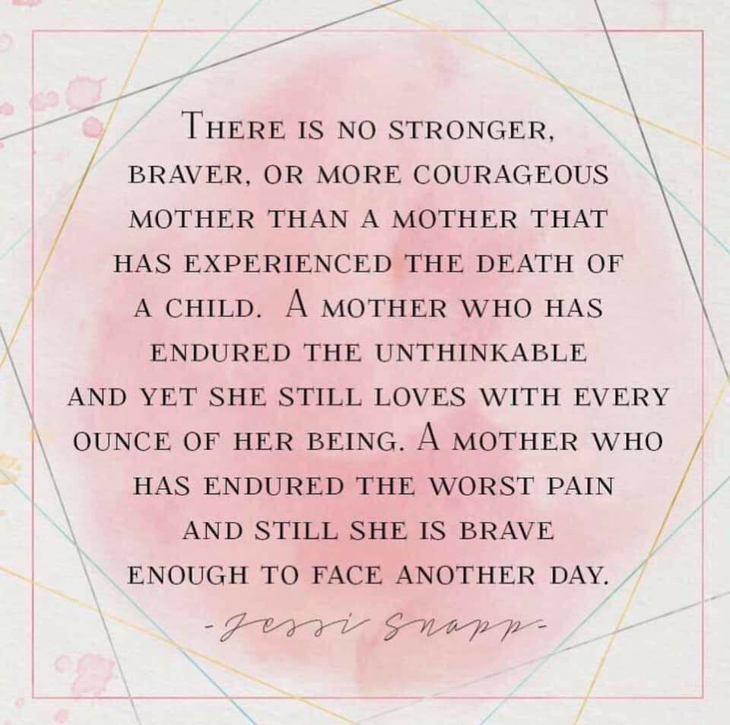

**Thoughts on the Month of May**

Spring flowers on your grave

express the time of year.

It used to be a busy time,

with lots of happy days and cheer.

I still have all the Mother’s Day cards

made of construction paper and glue,

verses written on a slant

that said, “Mom, I love you.”

I’ll make no special cake this May

nor see the graduation of your class.

The parades, ice cream socials and

parties are all part of the past.

And though these weeks bring sadness,

when I remember them I have to smile.

May was really very special

And I’m glad we had it for a while.

*--Norma Herzog, TCF Cincinnati, OH*

[](https://www.facebook.com/farsideoftherainbow/photos/a.265765910132193/3719425951432821/?type=3&eid=ARBkBG2loqv5RFXHNvpIXu1pFghs0oUsvoR9qPkXBwviTqejuRIaT2kunBoE4KKUJgqDAQcrtT1z2PYL&__xts__%5B0%5D=68.ARA39YWhRoxCpg5XFvOZq1crwQAtw0A5mxIPYd33S0yyDWAfVZD50qeTph9V9dT5jBZzBPGDPmuxVy-h8m0vI7HzKc2RHb2ykUExt6WcaNCJvUB6fVMw8b7bVlStBmXBsZYyDq2WMgYxCbqf1hiiU0_kJEYABwled7wFzwn7oIafRHF-30YUmprcD4udR9qJ_YYiDrqVcthLODaLIWbEiyaYfBHXM0RFZ633JMAyRZBcRSDEPaQOQI16jBFB2vfCqNd6DqK_1HQkJ3G4AIsmupWb7yBpEUE_aOAjJUnp0g7V7TyJvwaY4cB9So8DxJsPxSQf_F_pfXMACnplHjkllS-t1O49GbV5AgJHvjtAItLbuxwo&__tn__=EHH-R)

**My mom is a survivor,   
or so I've heard it said.   
But I can hear her crying at night   
when all others are in bed.**

**I watch her lie awake at night   
and go to hold her hand.   
She doesn't know I'm with her   
to help her understand.**

**But like the sands on the beach   
that never wash away  
I watch over my surviving mom,   
who thinks of me each day.**

**She wears a smile for others  
a smile of disguise  
But through Heaven's door I see   
tears flowing from her eyes.**

**My mom tries to cope with death   
to keep my memory alive.   
But anyone who knows her knows   
it is her way to survive.**

**As I watch over my surviving mom   
through Heaven's open door  
I try to tell her that angels   
protect me forevermore.**

**I know that doesn't help her   
or ease the burden she bears.   
So if you get a chance, go visit her  
and show her that you care.**

**For no matter what she says   
no matter what she feels.   
My surviving mom has a broken heart   
that time won't ever heal.**

~ Kaye Des'Ormeaux   
“The Lily Garden" painting by by Peggy Garr

**Mother’s Milk**

My body knows not That you are gone.

My breasts fill. My heart aches.

My moans replace All other sounds.

You are not in your rightful place.

My painful breasts are only a reminder now

Of what was supposed to be, but is not

*--Julie Fritsch*

**Memory**

I saw you standing on the shore

Where your sandaled feet will stand no more, Your daughter's hand

cupped in your hands,

Her chubby feet on wave-washed sands,

Joy shining in her baby face

At sharing in this sacred place.

I saw you standing there, my son,

Where dolphins play and waters run,

But you will never come again

To ride the waves as you did then,

For death has bleached your life to bones,

And your daughter walks the beach alone.

*--For Peter Nestojko*

*From Mom, Jeannie Nestojko, 5/31/99*

*TCF South Bay/LA, CA*

**Mother’s Day**

As Mother’s Day came and went, I sought out my box of memories. I went back to times when there were two cards, some homemade of construction paper with crayoned verses proclaiming me “the greatest Mom of all.” They were made in school with some S’s reversed and with no semblance of order.

Later came more sophisticated cards, store-bought, but with the same message, and the love was still there. I accepted them, loved being made to feel special, and tucked them away, never realizing how valuable they would become.

Now there is one card. There seems to be a double portion of love in that card, and I recognize and appreciate that effort. I am thankful there is one card, and I value very much what I have left.

My heart goes out to those of you who had no card this Mother’s Day. But even with the pain, I’ll bet if you were given the choice of no child/no pain, you would—like me—gather up as many memories as your child’s life span permitted and hold them close to your heart, sorry there wasn’t time for more, but never willing to exchange for no pain the pleasure of his or her company for however long you had them. When all is said and done, the memories are the important things. Relish them but gather about you all those you have left who love you and let them help you through this special day. It takes patience, but you will survive and go on to better days. I hope that your Mother’s Day was a peaceful one*.*

*–Mary Cleckley*

**No Vacation**

There is no vacation from your absence.

Every morning I awake

I am a bereaved parent,

Every noon I feel the hole in my heart.

Every evening my arms are empty.

My life is busy now, but not quite full.

My heart is mended, but not quite healed.

For the rest of my life every moment

will be lived without you.

There is no vacation from your absence.

*--Kathy Boyette*

*TCF Mississippi Gulf Coast*

One day as I was lying in a canoe, a black beetle came out of the water and climbed up into my canoe. I watched idly for a while. Under the heat of the sun the beetle proceeded to die. Then a strange thing happened--his glistening black shell cracked all the way down his back. Out came a shapeless mass and quickly transformed into a beautiful, brilliantly colored life. As I watched in fascination, there gradually unfolded iridescent wings from which the sunlight flashed a thousand colors. The wings spread wide as if in worship of the sun. The blue-green body took shape. Before my eyes occurred a metamorphosis--the transformation of a hideous beetle into a gorgeous dragonfly which started dipping and soaring over the water. But the body it left behind still clung to my canoe. I had witnessed what seemed to be a miracle. Out of the mud had come a beautiful new life.... And the thought came to me...that if the Creator works such wonders with the lowest of creatures, what may be in store for the human spirit? *--Cecil B. DeMille*

**Are You Somebody’s Mother?**

The waitress smiled sweetly as she passed out corsages. She stopped at our table, gave a corsage to my mother, then posed her question to me. “Are you somebody’s mother?” Be calm, be kind. She doesn’t realize the impact of her question. She doesn’t know my son, my only child, is dead. She doesn’t know he committed suicide a year and a half before. She doesn’t know the pain of every holiday, every birthday, and most of all, Mother’s Day! How do you rejoice in a day that brings such personal pain & anguish? Often moms receive cards, flowers, phone calls, gifts, hugs and kisses—but not me! “Are you somebody’s mother?” I used to be. I am!

*--Mildred Buss, TCF Montrose, CO*

###### Lilyfish

After the world takes an eggbeater to your soul, you never know what’s going to get you up and back among the living. In my case, it was the ham. It was 3:30 on a sweltering July afternoon, three weeks to the hour since my new baby daughter lay down for a nap and woke up on the other side of this life. I decided it was time to go fishing. There were any number of good reasons. For one, I could still smell Lily’s baby sweetness in the corners of the house, still feel her small heft in the hollow of my shoulder. For another, I’d hardly left the house since she died and had taken to working my way through an alarming amount of dark rum and tonic each night, not a sustainable grief management technique over the long haul. Jane and I had planted the memorial pink crepe myrtle and the yellow lilies, chosen for having the audacity to bloom in the heat of the summer, the very time Lily died.

But it was the ham that got me off the dime. After the funeral, the neighbors had started bringing over hogs’ hind legs as if the baby might rise from the dead and stop by for a sandwich if they could just get enough cured pork in the refrigerator. I knew my mind wasn’t quite right, knew I still hadn’t even accepted her death. But it seemed like I’d lose it unless I put some distance between me and the ham.

I shoved a small box of lures in a fanny pack, spooled up a spinning rod with six-pound mono line, and filled a quart bottle with tap water. On my way out the door I stopped, as I have taken to doing since her death, to touch the tiny blue urn on the mantel. “Baby girl,” I said. I stood there for several minutes, feeling the coolness of fired clay and waiting for my eyes to clear again. Then I got in the car and drove 20 miles north of D.C. to the Seneca Breaks on the upper Potomac River. I didn’t particularly care that it was 102 degrees outside. I didn’t particularly care that any small-mouth bass not yet parboiled by the worst heat wave in memory would scarcely be biting. I was furious at the world and everything still living in it now that my daughter wasn’t. As I drove, the radio reported severe thunderstorms to the west and said they might be moving our way. Fine by me. If someone up there want ed to send a little electroshock therapy my way, I’d be easy to find.

Even at 5:00 the sun still had its noon fury. The heat had emptied the normally crowded parking lot at the river’s edge. I stepped out of the air-conditioned car into the afternoon’s slow oven. I slugged down some water, put my long-billed cap on, found a wading stick in the under-brush, and walked into the river. The water was bathtub warm and two feet below normal. Seneca Breaks, normally a mile-long series of fishy-looking riffles and rock gardens, was, like the only angler fool enough to be out there, a ghost of its former self. At least it didn’t smell like ham.

MCj02408530000[1]

But the fish weren’t here, and I realized I shouldn’t be either. It dawned on me that I’d better get in water that went over my waist or risk heatstroke. Just upstream from the breaks, the river is called Seneca Lake, three miles of deep flats covered with mats of floating grass. I worked my way to the head of the breaks and slipped into this deeper water, casting a four-inch plastic worm on a light sinker. Soon I’d waded out chin-deep into the lake, holding my rod arm just high enough to keep the reel out of the water. There were baitfish dimpling the surface every so often and dragonflies landing on my wrist, and once a small brown water snake wriggled by so close I could have touched him.

Nothing was hitting my worm, but that was to be expected. My arms seemed to be working the rod on their own, and I was content to let them. I stood heron-still and felt the slow current brush grass against my legs. Every so often a minnow would pucker up and take a little nip at my exposed leg. It tickled. Baby fish. I remembered how I’d call her Lilyfish sometimes when changing her diaper, remembered how she had loved to be naked and squiggling on the changing table, gazing up at me and gurgling with something approaching rapture as I pulled at her arms and legs to stretch them. The tears welled up again.

I found the melody to an old Pete Townsend song running circles through my head and finally latched onto the chorus: "After the fire, the fire still burns, the heart grows older but never ever learns.” That’s how it was, alright. The fire was gone, but it still burned. It would always burn. The memories—her smell, her smile, the weight of her in my arms—would always smolder. And I’d always yearn for the one thing I’d never have. And what struck me as I stood alone in the middle of the river was that while my world had been changed forever, the world itself had not changed a whit. The river simply went about its business. A dead catfish, bloated & colorless, washed serenely past, on its way back down the food chain. The sun hammered down, and a hot wind wandered over the water.

I caught a bluegill, then too little smallmouths, within ten minutes of each other. As I brought the fish to the surface, I had the sensation of bringing creatures from a parallel universe into my own for a minute before sending them darting back home. I wondered if death might be like this, traveling to a place where you didn’t think it was possible to breathe, only to arrive discovering that you could. I hoped it was. The older I get, the more I believe that there is such a thing as the soul, that energy changes form but still retains something it never loses. I hoped that Lily’s soul was safe. That she knew how much she was still loved.

I don’t know how long I stayed there or even if I kept fishing. I remember looking up at some point and noticing that the light had softened. It was after eight and the sun was finally headed into the trees. And now, just like every summer night for eons, the birds came out: an osprey flying recon over the shallows 50 feet up; a great blue heron flapping deep and slow, straight toward me out of the fireball, settling atop a rock and locking into hunting stance. And everywhere swallows coming out like twinkling spirits to test who could trace the most intricate patterns in the air, trailing their liquid songs behind them.

Suddenly I wasn’t angry anymore. This is the world, I realized for the millionth time, and its unfathomable mystery: always and never the same, composed in roughly equal parts of suffering and wonder, unmoved by either, endlessly rolling away. It was getting dark now, hard to see the stones beneath the water. I waded carefully back to my car, rested the stick by a post for another fisherman to use, changed into dry clothes, and drove home.

Take your grief one day at a time, someone had told me. I hadn’t known what he meant at the time, but I did now. This had been a good day. Lily, you are always in my heart.

*--Bill Heavey, Editor/Author, Field & Stream. Permission to reprint granted by Time Warner & Field & Stream magazine.*

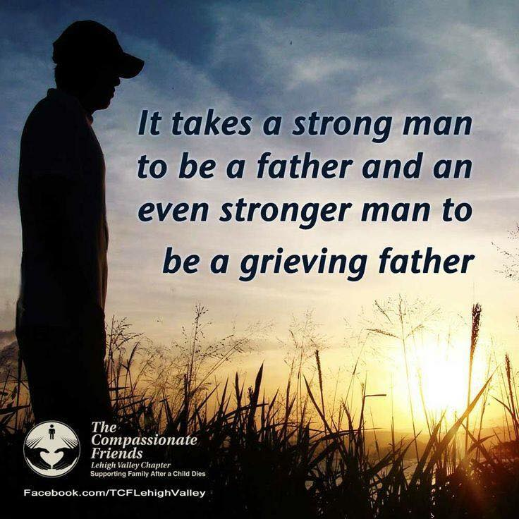

Some Thoughts on

Rebuilt Engines

Most of us reading this newsletter have experienced the shattering of our human machinery upon impact with a child’s death. Whatever helped us keep moving before, nothing works now. Our lives ground to a halt.

In the stillness of grief’s long night, I despaired over trying to repair something that would always lack a vital part. How could I ever rebuild the machinery of my life without that precious part? Any repair work would require my permission and participation. Looking at the tangled, damaged parts of myself, I questioned how to salvage anything workable from the wreckage.

Eventually, blessedly, the desire to move again, to get back into life’s traffic, got me doing something. At first it was tinkering, experimenting with the broken parts, imagining them whole again. Then I tried to learn by watching others who were rebuilding. It helped to read repair manuals, painfully written by people like me. The process was tedious and exhausting; there were setbacks, hidden costs, and false starts.

One surprising day my engine actually turned over—I moved a little. Before long, the motor sounded stronger. It almost seemed to hum, as I remembered it could. With persistence, I worked up to a decent speed, regained my sense of direction, and even began appreciating some sights along the way. I discovered that a rebuilt engine could carry me, despite the missing part. Occasionally it sputters, misfires, or floods, being sensitive to road hazards other drivers don’t see. Some hills always seem too steep, certain roads have too many memories, or the fog is too thick to drive through. When necessary I slow down, make adjustments, or pull off the road temporarily.

I wanted to write about my experience out of gratitude. Each of us has our own long night of grief and our own reawakening from it. The mystery of healing defies simple explanation. Do invisible hands help us in the healing process? I don't have an answer, just astonishment at the process which moved me from the tangled wreckage of myself to a sturdy rebuilt that appears whole, even though it isn't. the reason, it would be a month of Sundays

*--Joan Page, TCF, Miami, FL*

**When a House Is Not a Home**

Have you had trouble feeling at home in your house since your child died? Many people can’t face that place and those memories. As a result, they spend the years ahead running. They don’t know what they are searching for, but for something that will blot out the memories they once valued.

Yet, those memories refuse to go down without a fight, and they keep on popping up at the most inopportune moments. Maybe when you’re driving, for instance, or trying to carry on a conversation with a new acquaintance with whom you really don’t want to share your experience. Some people choose to move in an effort to leave old memories and pain behind. They haven’t learned yet that what you have in your heart and your head, you carry with you no matter where you go. It’s like you’re crawling, and grief is riding a bicycle, and it gets there ahead of you. Strange how grief seems to know your destination.

When grief is fresh, you’re not going to be happy, no matter where you go. Better than running or moving, this is a good time to use your time wisely. Learn how to live with your loss, which includes allowing your house to become your haven again—friendly, familiar and warm, full of memories that one day you will again find comforting. It happened for me, and it can happen for you. Soon, I hope.

*–Mary Cleckley, BP/USA*

**There Is a Room**

There is a room in our home whose door is closed. I open it from time to time and pause awhile. The red carpet is somewhat stained, an oil spill, perhaps. Hair oils darken the wall beside where the bed once stood. A candy wrapper, a popcorn kernel or two, lie beside the roller skates.

All of this hid in the dark beneath the bed. Now the bed is gone, as are most of the clothes. Dressers standalone around the desk, drawers full, cluttered with mementos. The closet holds a few tools, a batter’s cap, a down vest, a fishing pole.

It is Olin’s room. Here he lives in memory only. I stand quietly and remember waking him up in the morning, starting the day. Within these walls we talked a lot, sometimes in anger, often with love. In here I cared for him when he was sick. Sometimes we’d wrestle, laugh, look at papers, see a drawing. In this place I held him in my arms, dried his tears, kissed him good night.

There were hard moments, too, within these walls. They have heard arguments, lectures, seen him placed across my knee. But mostly they witnessed hugs and closeness, caring and love.

In this room I hear the whispers of our yesterday and know I love him still. Someday this room will be a den, but not too soon. I’ve taken care of some furniture, but not all. Some things have been discarded, but not too much. A few things have been stored away, but there’s a lot to go.

There is still much to do, transforming this part of my past. It’s like my soul: a little cluttered, a bit dirty, just partially picked up. In its slow transformation back to life I say my goodbyes. Mostly, though, I watch my now; blessed and built-in countless memories unfold to the future.

*--Don Hackett, TCF,*

*South Shore, Boston, MA*

**Daddy, Fix It**

A broken toy? Daddy, fix it.

Wagon broken? Daddy, fix it.

Dolly needs a new eye? Daddy, fix it.

Faucet leaking? Daddy, fix it.

Need new wall paneling? Daddy, fix it.

Anything need rebuilding or repair?

Daddy, fix it.

And why not?

Daddy has hundreds of different sized screws, nails, bolts, nuts & washers;

he has all sizes of screwdrivers;

he has all sizes of hammers from a 12-lb. sledge to a 3-oz. brad hammer;

he has a brace and bit set, a hand drill,

electric drills, all sizes of bits to go with the drills;

he has several sets of wrenches, even some metric ones;

he has cheap tools,

and some very expensive tools,

and he has books to tell him how to fix it.

If Daddy doesn’t have the tool or the specialized knowledge,

why the Ace Hardware Man or

True Value Hardware or the Sears Roebuck Store…

will have what he needs to fix it.

Except the last time.

Oh, he still had all of his plain and fancy tools, all of the screws, nails, bolts and nuts, and all of his books.

But even Ace, True Value and Sears

couldn’t help him—not this time.

Daddy, fix it.

Except the last time.

Death.

Daddy couldn’t fix it.

*--Tom Crouthamel, TCF, Englewood, FL*

**The Dust**

The dust sifts down

onto unused furniture,

onto beer cans

carefully collected and arranged.

Dust is covering my memories too,

blurring the outlines,

muting the colors,

softening the rough edges

that made you so vibrantly alive, human.

I can dust the furniture

until its shine almost convinces me

that someone lives in this room.

But who will brush the cobwebs

from my mind,

bringing you into focus

once again?

*--Ellin R. Langford, Washington, PA*

**A Time to Remember**

Memorial Day is for memories.…As a teenager, I recall putting flowers on my grandfather’s grave; it was something I felt I had to do that took a few minutes of my holiday. Now, placing flowers on a grave on Memorial Day is something I want to do. The significance of the day has changed since those earlier years, because now it’s my brother who is buried.

Jerry’s death at age 21 in a truck accident was unexpected and shocking. I have never felt such grief before—grief so strong that even as time tries to heal the pain, the scars remain. That’s why Memorial Day for me is no longer what it is for so many people—little more than a long weekend, a day off from work, and the beginning of the swimming and boating season. The day now holds special meaning. While at other times of the year I get teary-eyed when a picture or a person brings back thoughts of Jerry, today my emotions are especially sensitive.

Memorial Day weekend is an opportunity for our family to take time out of our busy lives to reflect on Jerry’s life. We share our thoughts, remembering certain things he did that made us laugh. But sadness lingers not far away. At one point, laughter turns to tears as Mom and I tell Dad about when she presented me with a plastic bag that contained Jerry’s white tube socks (his trademark), a cigarette lighter and a wallet. These were the last tangible reminders we had of him—taken off his body and given to us after the doctors said there was nothing more they could do for his serious internal injuries. What solemn reminders of how quickly life can turn to death.

But these are moments we can talk about to keep him close in mind and heart. Thursday evening my parents and I stay up late going through a stack of memorial clippings, searching for just the right poem that will reflect Jerry’s personality and capture our feelings, so we can publish it in our newspaper’s memorial tributes. Memorial Day itself is a time to leaf through scrapbooks and read the hundreds of sympathy cards we received, remembering the outpouring of love and support we got and realizing that our mourning is far from over. Sunday, as we put our flowers on Jerry’s grave and read two poems in memory of him and our other deceased loved ones, I feel a strong sense of family. These people understand how I feel. It is okay to cry. And as strangers drive by in cars and line the roads of the cemetery to pay their own respects, I feel I am not alone. We all share something. That’s what Memorial Day is all about.

*--Dawn Morville, TCF sibling*

**Upcoming EventS:**

Mark your calendar for Eastern Jackson County’s Walk to Remember on September 21, 2019 at Waterfall Park in Independence, MO. More details to follow

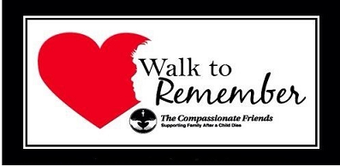



# 42ND TCF NATIONAL CONFERENCE

## JULY 19 - JULY 21

If interested in attending the Conference, go to [www.compassionatefriends.org](http://www.compassionatefriends.org) to register before June 15. I recommend booking your hotel ASAP to guarantee a room at the event.

# Love Gifts

***Thank you for the generous donation from Mark Fanning in memory of his son, Marcus.***

**Please help us help others. Make a LOVE GIFT today**. **Tax deductible Love Gifts may be sent to: TCF C/O Theresa Phillips 6200 Kentucky Ave, Raytown, MO 64133**

*For Remembrance dates please visit our website at* [*www.easternjacksoncountytcf.org*](http://www.easternjacksoncountytcf.org)

*Find us on Facebook at* [*https://www.facebook.com/groups/1582699755290182*](https://www.facebook.com/groups/1582699755290182)

*We have several volunteers who write remembrance cards to families on birthdays and death dates. Just a reminder if you have an address change please email* [*phillipsplace@aol.com*](mailto:phillipsplace@aol.com) *or mail a note to TCF, C/O Theresa Phillips 6200 Kentucky Raytown, MO 64133 so the roster can be updated.*

*Please remember that you can give to The Compassionate Friends through your United Way pledge at work or as a single gift, but you MUST WRITE IT IN.*