

July - August 2021

**Chapter Leader: Theresa Phillips TCF National Headquarters**

# 24-Hour Help Line: (816)229-2640 48660 Pontiac Trail #930808 Wixom, MI 48393

**Private Facebook Page: Eastern Jackson County TCF Website: www.compassionatefriends.org**

**Website: www.easternjacksoncounty tcf.org (877)969-0010**

**Vacations After Loss**

Vacations bring to mind time we spent as a family. After the death of a child, vacations—especially the first ones after loss—remind us of their absence.

Some bereaved parents place a higher expectation on the vacation than can be fulfilled. Mom may assume that getting away from home and the stress of work will enable Dad & other family members to talk about their loss, recalling memories together and resolving issues of their grief. Dad might be thinking, “If we can just get away from all these memories and stress, we can relax and forget our pain.” It’s not uncommon to discover one spouse may not be ready to talk yet.

It would be good for each family member to express their expectations for vacation, their fears, and other factors so that the family can have an idea of what everyone is expecting before they take off. It will be less frustrating for everyone if they know the time will not ALL be devoted to one person’s expectations. Knowing that some time may be set aside for grief work, some for Dad and Mom’s relaxation, and some for other family members’ enjoyment, will make it less stressful for everyone.

If vacations usually include trips to relatives or family camps, seeing everyone after your loss can be bittersweet. Memories as well as what you’d planned for your child to do flood your mind. Some people will want to talk about your child. If your trip occurs shortly after the funeral, you may find that talking about your child is like dragging the funeral out for days. When several months have elapsed, others often feel uncomfortable and will not mention your child’s name until you do. If you want to talk about your child, don’t wait for others to bring up his/her name. They’re uncertain if you’re comfortable talking about him/her, so are waiting for you to make the first move.

Many find the enthusiasm to plan vacations and the concentration to make detailed arrangements are gone early in their grief, the first year especially. Others feel too stressed out to go anywhere or are afraid that coming home would be too painful. In that case, day outings might be more suited to your energy and enthusiasm levels. Try to choose a variety of things so that each member of the family can do something they enjoy.

Some bereaved parents may fear getting too far from home and the mementos that remind them of their precious child. Various fears, some irrational, may make thoughts of a vacation too painful to consider. In such a case, it would be good to try to define these fears. Just realizing what the fear pertains to helps you deal with it. If fear is a problem with any member of the family, it would be good to make a list of what they are afraid of, then calmly discuss these fears with someone. If it’s too stressful to discuss them within the immediate family, ask a trusted friend or pastor to discuss them with you. Just getting them out in the open and identified will help immeasurably.

Many recently bereaved people find that too much free time allows more time for painful remembrances than they welcome, **so it’s important to be flexible** and willing to change plans midway through the vacation, if it’s agreeable with the majority of the family.

Discuss the pros and cons of visiting a familiar or a new place, to decide what each family member feels most comfortable with. Remember grief depletes your energy levels, so you’ll tire more quickly. Take this into consideration when planning reasonable distances to be driven daily. Bereaved people need exercise, but if you’re planning to hike or do other strenuous exercise, don’t forget your energy levels are not the same as they were before your child’s death. Exhaustion and disappointment with your capabilities (thus frustration) will come much sooner than previously. Whether you leave town or stay home, remember **working through grief is the hardest work you’ll ever do.** Be kind to yourself and allow time to reenergize your own depleted reserves.

As in other family matters, **communication is very important.** No one else can read your mind and be able to fulfill your unexpressed expectations. For a vacation to be refreshing for everyone, good communication will be one of the most important factors. You may have been planning a very special vacation and wonder if you should take it so soon after your loss. You might consider waiting another year so you can enjoy it more with less “grief baggage” than you are carrying now. Or you may feel that since you have been anticipating it for so long, to put it off would just be another loss added to your child’s death. **Only you can decide.** If you can’t decide peaceably, that’s an indication you won’t enjoy it as much now as you most likely would in a year or two.

As with everything else after loss, the first vacation will be the most challenging. It’s all new with that huge absence every present. It would be nice if a vacation were an opportunity for you to escape your pain or leave it behind at home, but the fact is, **everywhere that love goes, grief goes too!** We grieve because we love. As time passes, vacations won’t be edged with as much pain. Someday you will find one enjoyable again.

*--Carol Ruth Blackman*



**Bereavement Balance Beam**

Notice the athlete as she carefully and gracefully strolls across the balance beam. She makes it look so easy. We watch and hold our breath, hoping she won’t fall. She artistically swivels at the end, goes back to the middle, and without missing a beat, lands perfectly on the mat below.

I am not an athlete, nor an acrobat, yet I walk a balance beam every day. I trod gingerly across the beam. I know you have not noticed. I hold my breath, not as a spectator, but as a participant. I wear an outfit, not of spandex or sweats, but of steel-plated armor guarding my emotions. I give a presentation of poise and control, which I’ve learned with each step I’ve taken. I know how to survive, take each day one step at a time; sometimes pausing for laughter, sometimes trembling with tears.

Then there are the times I’ve fallen off, which in the beginning took only a mere reminder of whom I’ve lost. What caused the fall? Perhaps a mention of his name, hearing his favorite song, seeing a boy on a bicycle and knowing it wasn’t James, seeing a mom at the store shopping for back-to-school items, watching someone else’s child at the soccer field, driving in the car with no one in the passenger seat.

But I learned to stay on the balance beam, handle those moments of pain and loss, keep my composure, let the tears fall, but not let my steps falter, turn the corner without tripping, keep life in balance and in perspective with a huge void on the other side. Now, almost five years later, I’ve nearly perfected this trick. I can’t compete with the professional athlete; they have the physical, visible aspect of this performance down pat. I’m still working on the emotional, mental portion, but doing quite well.

--Until I hear my niece gets to be a mom, my sister-in-law moans that her son is away for a week and the house is so quiet, or yet another friend has become a grandmother, someone else we know is graduating or marrying, or my nephew turns 16 and gets a license. All are reminders of whom I’m missing, what James never will accomplish—the opportunities that James missed out on, the life I wish I could see James experience.

It’s all a matter of balance, keeping the stride, maintaining a sense of normalcy—balancing, in spite of a broken heart and an emotional handicap. And I know that when I fall, there are friends to help me back up, memories that make me smile, determination to live the life James would have wanted—for both of us.

*--Meg Avery, in loving memory of James R. Avery III*

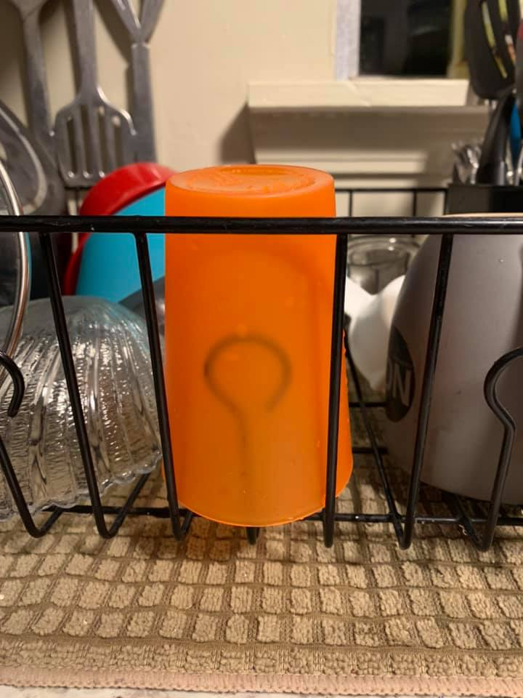

**I washed the orange cup today**.

“The orange cup” is not a metaphor. It’s a small, plastic cup—one of several in a multicolored set. It is small, and just perfect for the bathroom sink. It’s just big enough for a sip of water in the middle of the night, or to wash down daily meds. I had not washed it since before January 1st. Before you get too grossed out I had not used it either. You see, that little orange cup is the last thing in the house that Mark’s lips touched on January 1st, before he was loaded into an ambulance never to return.

I had picked up the orange cup several times before, thinking it was time to wash it and put it away. But each time it wasn’t. I would hug that little cup, cry a little (or a lot) and return it to the counter next to the sink. It wasn’t time to wash it—until today.

Today, I washed the cup.

When my mother died, her house coat (bath robe) was hanging on the back of the door in the bathroom. When my Dad died 5

years later, it still hung in the same spot. He had given away or tossed a lot of Mom’s items, but just not that house coat. Had he lived another 10 years, I think that it may still have been there… or maybe not.

Deep, profound grief is just weird. So, keep that in mind when you wonder why grieving people do (or don’t do) what you think they should do, or what seems normal. Grief is really weird. They’re just not ready to wash the cup.

--[**Amy Boardman Rejmer**](https://www.facebook.com/amy.b.rejmer?__cft__%5b0%5d=AZXEuHZLC6sgPLP4IkYzMUT08vJgzGSrkv785mAp0Di4FqX9BYRcp2DFX-nno_g-Epx6vfd3jv9IqWMrB7w261EWcYTIvrN2HMcc0zgy000ThuUf8bB2X3AdVLn7uJFq8I5IVO9sRFv7oVm2CBnzHOK_LLeeY2lk4TrojDkZsuqQUZowaieqKusbVtrF5eb5SqYmyoVlyj8cmf7kRLEpHPA1&__tn__=-UC%2CP-y-R)

**I Still Love**

She brought me red roses tonight, the ones she knew I loved. I thanked her silently and watched as she sat against the nearest tree. She looked past me up toward the twilight sky. Her mouth was slightly smiling. Yet she had tears in her eyes. Her one hand tucked her auburn hair behind her ear and her other hand was twirling the grass between her fingers. She shivered a little and I wished I had my jacket to give her, a hand to comfort her. I wanted to tell her I loved her again, but it was as futile as trying to make roses grow in the dark. I wanted to kiss away the tears that were now streaming down her upturned face. I wanted things like before when the world could make her laugh. She held one more rose, the most beautiful one, the one that had bloomed in her hand. She walked through the vacant space between her and me. I smiled in wonder as she tried to wipe away her tears. With a shaking hand she let down the final rose upon my grave and made her way toward the setting sun.

*--Alysa Mayer in memory of Keith*

**River With One Stone**

*By Pat O'Donnell*

That day our world consisted of small differences and distinctions determined by the particular place we sat in this river transporter of rubber and air. My chosen seat was in back to better safeguard the little one at the beak of the boat. My mind tells me it was only yesterday when I saw the look that questioned my decision and said how come you won't be next to me? How could I explain that I loved him so much that I would sacrifice sight of laughter on his face to make sure he was ok? Better to be behind the precious one in guardian mode for a Dad that was worried about coming walls of water washing this perfection from Dad's loving eyes. That would never happen, would never be allowed and a father's fear of his own demise was no barrier to any effort to protect this most special love from real harm. Real harm was inconceivable, unacceptable.

Our memories were together on the shore looking at this river that flirted with our toes. It was cold as the kind you want on the hottest summer day. It was clear to the bottom of its center. Harmless moving fishy colors occasionally cast shadows on the brilliant golds and whites of the pebble bottom that decorated the depths of this calmly forever-moving liquid path. We would leave this river of life only briefly. The shore was not our home on this journey. On occasion our adventure encouraged brief heat relieving respites from our watery friend to gain perspective on our trip from a different view. To rest and observe the river of our destiny could provide great insight into the bigger picture. And it was fun. Our skin absorbed rays of light and in small proportions this felt good. The warmth was contrasted with the water at our feet. Shapes and sounds and colors were gloriously in place and there was great comfort in the reassuring order of this world as we splashed back into our raft and its river road. Our waterway was always there, always holding our past and future in timeless travel for a father and son in a lifetime voyage to our destiny.

We left our river that day but kept momentous memories forever tucked away in father and son time. Adventures continued but on different paths as souls find their own way. One

day it was time to reenter our adventure and travel back to the river, our river. This time I heard only one splash. And it was mine. Looking back on the shore there was the solitary figure waving, smiling, and speaking without being heard from the shore that was now his home. See you soon was the song but my tears on the river was the only sound I could hear. The current had a hold of me, and all of my fatherly strength could not stop the inevitable. My little friend was not alone, and his smile showed great happiness. There was great peace all around him as he bathed in familiarity. He was ok. My tears were as plentiful as my screams, but deafening silence was the response to my pleadings. My being was numb as exhaustion claimed victory over the powerless in this unfair fight. In an instant the journey had changed forever. In an instant the lesson of Love was taught in this river with the shore that was not mine, not yet.

And so another day is noted where the sun shines only briefly. Another night is endured when the moon is buried behind dark shadows. The day is singularly sad and so is the man though no one sees. Strangers, family or friends are not supposed to spy even a hint of the man and the tragic baggage attached to him by the death of a child. Suffer in silence is the motto passed from generation to generation. There is not enough time for the luxury of grief. There is money to be made or beasts to be slayed. Food and shelter must be gained and provided. Life goes on. Happy Father’s Day hurts so very much but no one knows because no one is supposed to see the heartache deeply buried in masculine moist eyes. The painful expressions stay in the private closet that Dad has built for his tears.

On Father’s Day, On Mother’s Day, on Birthdays, on most every day there is a profound sad loneliness locked in memories that sometimes escape their storage area. Still floating in the river, still leaving to walk on a shore and look out into forests, and mountains, and empty land for the son that travels no more in this river. Sometimes, on occasion, I know I see him, if only for an instant, just as I last saw him so long ago on the river with one shore and he is just as perfect as ever. Now I sit in the front of the air and rubber raft and my most precious child sits in the back. Someday we will sit side by side.

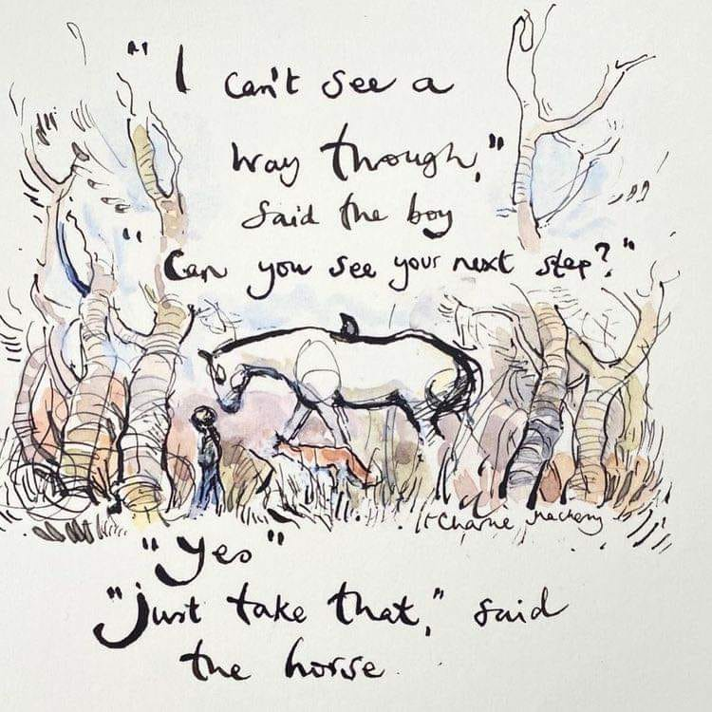

**Freedom Is Not Free**

I watched the flag pass by one day.

It fluttered in the breeze.

A young Marine saluted it, and then he stood at ease.

I looked at him in uniform So young, so tall, so proud

With hair cut square and eyes alert

He’d stand out in any crowd.

I thought, how many men like him

Had fallen through the years?

How many died on foreign soil? How many mothers’ tears?

How many pilots’ planes shot down?

How many foxholes were soldiers’ graves?

No, Freedom is not free.

I heard the sound of taps one night

When everything was still.

I listened to the bugler play and felt a sudden chill.

I wondered just how many times

that taps had meant “Amen”

when a flag had draped a coffin of a brother or a friend.

I thought of all the children,

Of the mothers and the wives,

Of fathers, sons and husbands with interrupted lives.

I thought about a graveyard at the bottom of the sea,

Of unmarked graves in Arlington.

No, Freedom isn’t free!!

--Kelly Strong

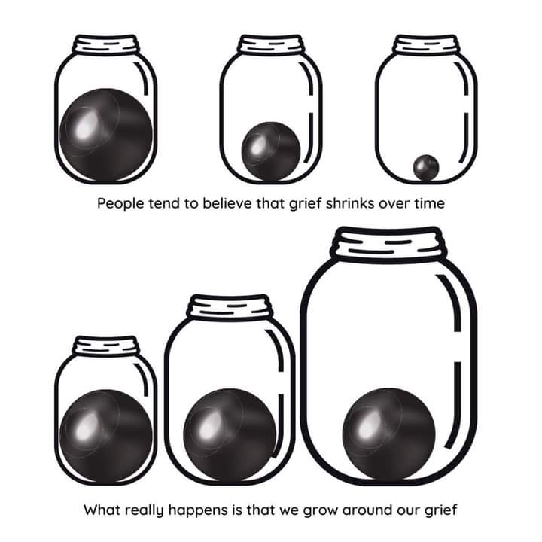

**Fireworks Are Like the Love in Our Hearts**

July brings central Oregonians lingering blue skies, lazy afternoons and the Fourth of July celebration, complete with the grand fireworks finale bolting from the top of Pilot Butte. This was one of my son’s favorite holidays. When he was six, I asked him why fireworks were so special to him. He said, “The lights explode in the dark and make the whole sky light up! The fireworks are like the love in our hearts. We should always try to spread our love out to others.”

Profound wisdom comes from the lips of children! From that summer on, in my mind, fireworks have been a triumphant testament of love’s enduring power and wonder. I miss my son, Joshua, terribly. I comfort myself knowing that his wisdom and kindness were precious gifts in my life.

Wherever you are on the Fourth of July, I hope that the splendor of sparkling fireworks comforts you and reminds you that the love you hold for your child is the light that is able to shine through you, for others.

We all have known grief well, yet as Compassionate Friends, we need not walk alone in the darkness. We can lighten the path for each other. Life can cripple and destroy us, but when we gather to share each other’s burdens, we are able to gain strength. Love for our children is our common flame; sharing and caring keep the flame alive.

*--Jane Oja, TCF Central Oregon Chapter*

Let warm memories

Be as close to you

###### 

###### The Promise

Your birth brought me starshine,

the moon and the sun;

my wishes, dreams gathered

‘round my little one.

My life became sacred,

full of promise and light,

all wrapped in the girl-child

bringing love at first sight.

The years of your living,

filled with laughter and tears

excitement, adventure,

some boredom, some fears,

but ended too quickly,

ahead of its time.

The loss so horrendous

such heartbreak was mine.

But from the beginning,

one thought rose so clear;

never would your death erase

the years you were here.

I would not be defeated

or diminished by your death;

I would hang on, learn to conquer,

if it took my every breath.

For if your death destroyed my life,

made both our lives a waste,

it would deny your life’s meaning\

and all the love you gave.

I vowed that years of sadness

would change, with work and grace,

to years of happiness, even joy,

in which you’d have a place.

Memories of you, like shining stars

in the patterns of my soul,

are beacons flashing light and love,

and with them I am whole.

In your honor, I live my life,

now living it for two.

Through all my life, you too will live,

You lived…you live…you do.

*--Genesse Boudrea Gentry*

As the warmth of summer

The child who owns this summer is not here,

not here to know the wealthy summer wind,

not here to share the glowing and the song.

The child who owns this summer did not live,

not live to touch the richness of this day,

this day in summer, when you are alone.

Cry to the summerwind

Cry, and behold the child

You remember.

*--Sascha Wagner*



**The Gift of Someone Who Listens**

Those of us who have traveled a while

Along this path called grief

Need to stop and remember that mile—

The first mile of no relief.

It wasn’t the person with answers

Who told us of ways to deal

It wasn’t the one who talked and talked

That helped us start to heal.

Think of the friends who quietly sat

And held our hands in theirs.

The ones who let us talk and talk

And hugged away our tears.

We need to always remember

That more than the words we speak,

It’s the gift of someone who listens\

That most of us desperately seek.

*--Nancy Myerholts,*

*Waterville/Toledo TCF*

Accept me as I am

grieving, pained.

empty, lonely

Just love me

and allow me to feel

what I must feel.

One day I will begin to heal--

I know not when.

Don’t be afraid of me—

It is still me.

Struggling to find

myself—outside

of this pain. Please

just be my friend.

*--Marilyn Henderson,*

*TCF Pacific Northwest*

**In My Pocket**

I have memories in my pocket.

They rattle just like change.

My memories of you are treasures

I carry wherever I go.

They are stored in bits and pieces,

parts of a beautiful whole.

They give me comfort

when I think I am alone.

Yes, I have memories in my pocket,

like so much other stuff I keep there.

But of all the treasure I have,

it’s the memories of you

that are the most precious.

*--Martin Baer, TCF North Shore-Boston*

**The Miracle of You**

Who could have known the exquisite difference

Your brief life would make upon mine?

Who could have known a tiny baby would

Show me the beauty of a sunrise,

Or the wonder of a rainbow,

or the pain of a tear?

Who would have known that an innocent little child

Would take away my fear of death

and point me in the direction of Heaven?

Who could have known that you

would succeed where so many others

have failed?

*--Dana Gensler, TCF, South Center KY*

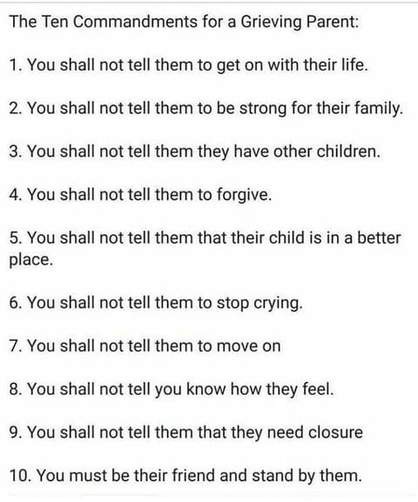

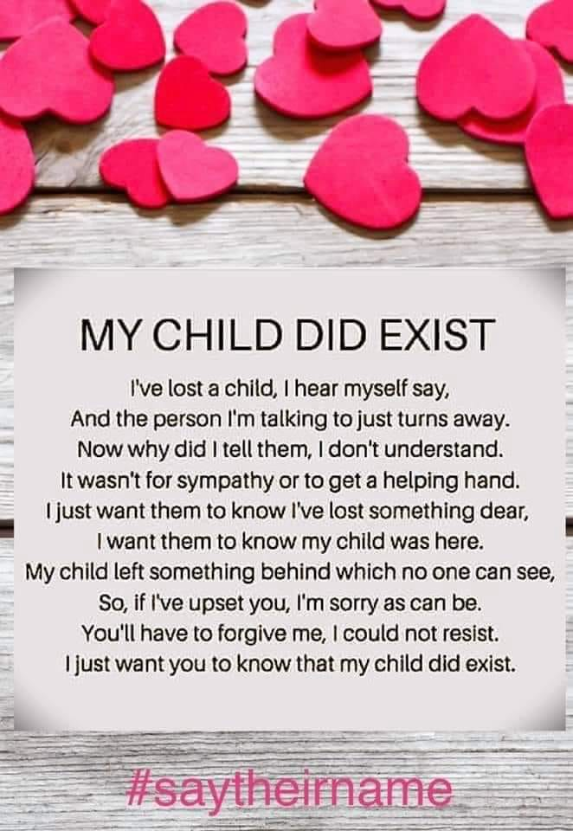

**TO HONOR YOU**

To honor you, I get up everyday and take a breath

And start another day without you in it.

To honor you, I laugh and love with those who knew your smile

And the way your eyes twinkled with mischief and secret knowledge.

To honor you, I listen to music you would have liked,

And sing at the top of my lungs, with the windows rolled down.

To honor you, I take chances, say what I feel, hold nothing back,

Risk making a fool of myself; dance every dance.

You were my light, my heart, my gift of love from the very highest source.

So everyday, I vow to make a difference, share a smile, live, laugh and love.

Now I live for us both, so all I do, I do to honor you.

***By Connie F. Kiefer Byrd, In Loving Memory of Jordan Alexander Kiefer 8/24/88 – 12/13/05***

**Back to School**

A time of year approaches which makes me sad;

Stores have on sale pens, papers and note pads,

Blue jeans, shirts, jackets, and of course, shoes.

School is starting—thus for me, a time of the blues.

Memories come back when buses start to roll,

Of when my son was with us…of days of old,

Memories of his eleven years of school,

Crayons, papers, stories, and learning new rules.

Friends, close “buddies,” girlfriends and all.

Glasses & braces, …

Yes, you can wear them and still play ball.

“Will you buy me an instrument? I joined the band today.”

“Is this hat too big? How can I march and make it stay?”

“I need a car, come on, Mom and Dad…what do you say?

“I’ll ride the bus some, plus work part-time, I’ll help pay.”

“Got a school trip tomorrow with the Spanish class.”

Drove his car to cash a paycheck.…

I thought he’d be right back.…

Yes, seeing school buses still makes me sad,

But for my memories, I’m thankful, I’m glad.

*--Jess Johnson, TCF, Wilmington, NC*

*__________________________*

I would straighten your tie,

smooth your collar,

pick a bit of lint from your sleeve

before you left for your day’s affairs

and I turned my attention to mine…

Today I brushed off a leaf

That had fallen on your name.

*--Doris Alsup, Burleson, TX, TCF*

**The Boy Who Wasn’t There**

I looked for you today, the boy who wasn’t there.

I looked for you among the children going off to school.

I looked at their new and shiny shoes and watched for untied laces.

I looked at their smiling faces, looking for a familiar crooked grin.

I looked for you today, the boy who wasn’t there.

I looked among your friends who played on a playground memorialized for you.

I looked at those bouncy heads as they skipped and played,

looking for a cowlick that stuck up just right.

I looked at them as they traveled home, bubbling with stories to tell about their first day at school.

As you tuck your children in bed tonight, give them an extra hug;

a thought, a smile, a prayer…for the boy who isn’t there.

*--Margaret Mlendez, Racine, WI*

*­­­­­­­­­­­­­­­­­­­­­***Labor Day**

The unofficial end of summer. The time by which we need to have new school clothes and supplies. The time to begin meeting new teachers and new friends.

The time to…what? To see other parents standing with their eager little ones, waiting for that first school bus ride to the big school. To watch with tear-filled eyes as the bus picks up their children for school, but no longer stops by our house.

Time to watch with anxious anticipation as the kids begin middle school. New experiences, new expectations, new fears …. Time to learn that saying “I love you” must be done in private. Time to realize that with us, “I love you” will always be said in silence.

Time to watch our teenagers experience high school and its freedoms and decisions.…Time to wonder what temptations await our children, to wonder about that car they bought, to realize all these things are happening to some other parents.

Time to buy single bed linens for the college dorm. Time to buy a new computer to take to school and keep the old one for us.…Time to listen to other parents talk about these events.

No, for us Labor Day is just that—a day to labor through the memories left behind by the loss of our child, a day that truly signifies the end of the summer of our life.

*—Sandra Wright*

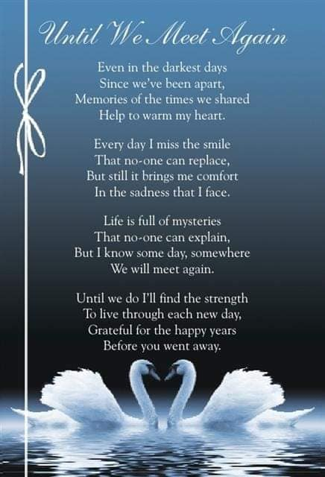

# Love Gifts:

**Please help us help others. Make a LOVE GIFT today**. **Tax deductible Love Gifts may be sent to: TCF C/O Theresa Phillips 6200 Kentucky Ave, Raytown, MO 64133**

**Remember when you came to your first meeting and someone was there who was a little farther down the road and gave you a hug or shared something that made you feel like you are not crazy. Well, if you are a little bit farther down the road, please feel free to come back to our meetings and help families that are just starting their grief journey.**

**Mark your calendar for these upcoming event:** The Compassionate Friends

2021 Virtual National Conference

July 16 – 18, 2021 Register online at www.compassionatefriends.org

I personally enjoyed the virtual conference last year. I found it to be a healing event. I am looking forward to this year’s conference. There are over 100 workshops to choose from.

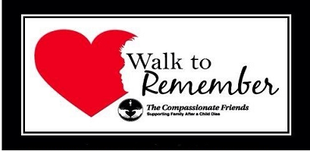

Eastern Jackson County Annual Walk to Remember is scheduled for September 18, 2021 at Waterfall Park in Independence, MO. Registration will start at 8:30 AM. Walk will begin at 9 AM.

*Please visit our website at* [*www.easternjacksoncountytcf.org*](http://www.easternjacksoncountytcf.org)

*Find us on Facebook at* [*https://www.facebook.com/groups/1582699755290182*](https://www.facebook.com/groups/1582699755290182)

*We have several volunteers who write remembrance cards to families on birthdays and death dates. Just a reminder if you have an address change please email* [*phillipsplace@aol.com*](mailto:phillipsplace@aol.com) *or mail a note to TCF, C/O Theresa Phillips 6200 Kentucky Raytown, MO 64133 so the roster can be updated.*

*Please remember that you can give to The Compassionate Friends through your United Way pledge at work or as a single gift, but you MUST WRITE IT IN.*